**LinkedIn -**<https://www.linkedin.com/in/bhavuk-chawla/>

**Course GitHub -**<https://github.com/bhavukchawla/Machine-Learning-Fundamentals>

**Email -** bhavuk@datacouch.io

**Phone -** +91-9911157206 (WhatsApp & Voice)

**Day 1: AI & ML Basics**

**Installing Anaconda**

<https://www.anaconda.com/products/individual>

Adding AI to applications in an easy way -

<https://www.youtube.com/watch?v=Nd4FL62bJOo>

Path for ML & AI -

<https://elearning.datacouch.io/blog/213584/machine-learning-path-recommendations>

AI Phone call - <https://www.youtube.com/watch?v=JvbHu_bVa_g>

https://www.bostondynamics.com/atlas

<https://shop.bostondynamics.com/spot?cclcl=en_US&pid=aDl6g000000XdpZCAS>

<https://cloud.google.com/blog/products/gcp/how-a-japanese-cucumber-farmer-is-using-deep-learning-and-tensorflow>

https://www.how-old.net/

<https://cloud.google.com/vision/docs/drag-and-drop>

Command to serve the slides from Jupyter Notebook -

*jupyter nbconvert AI_ML_Concepts.ipynb --to slides --post serve*

*Glossary of ML*

<https://developers.google.com/machine-learning/glossary>

*Big Data Logical Arch -* [*https://www.youtube.com/watch?v=yJCbyBC6Puc&t=440s*](https://www.youtube.com/watch?v=yJCbyBC6Puc&t=440s)

*Video to Whip data - Microsoft*

[*https://www.youtube.com/watch?v=XzG1a46yZHQ&t=1772s*](https://www.youtube.com/watch?v=XzG1a46yZHQ&t=1772s)

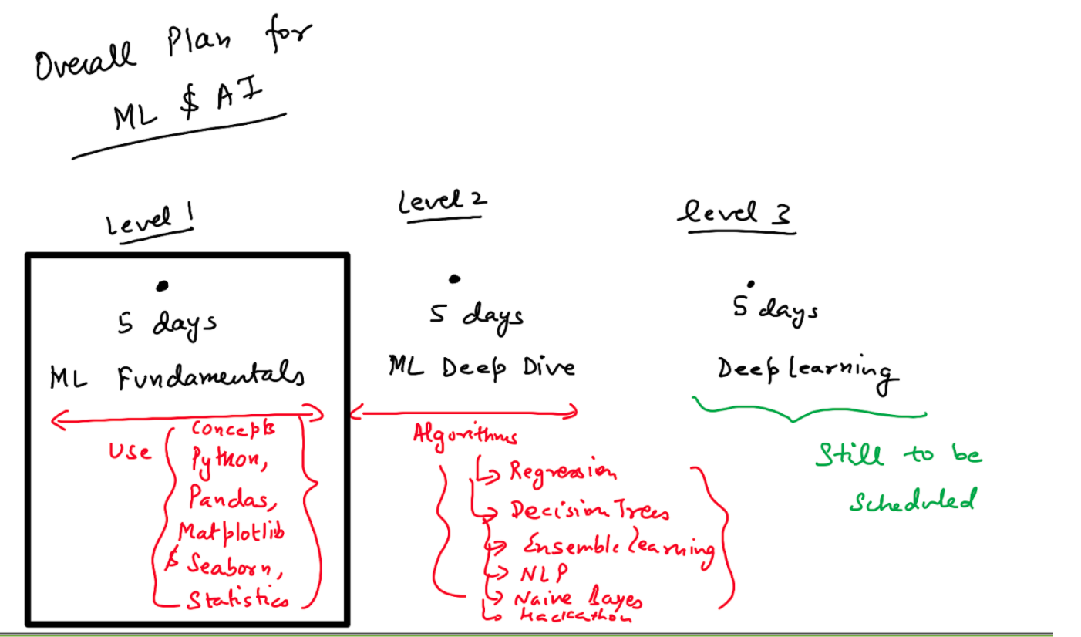

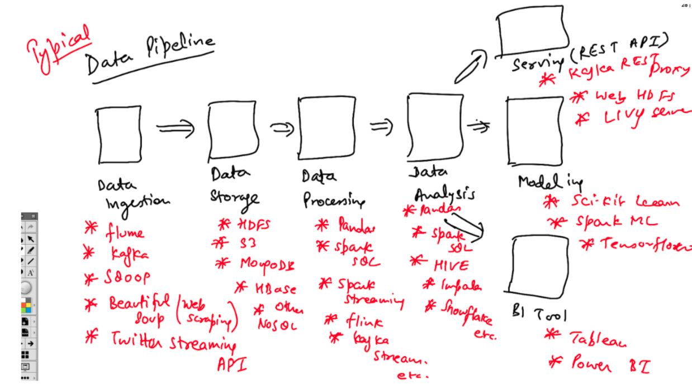

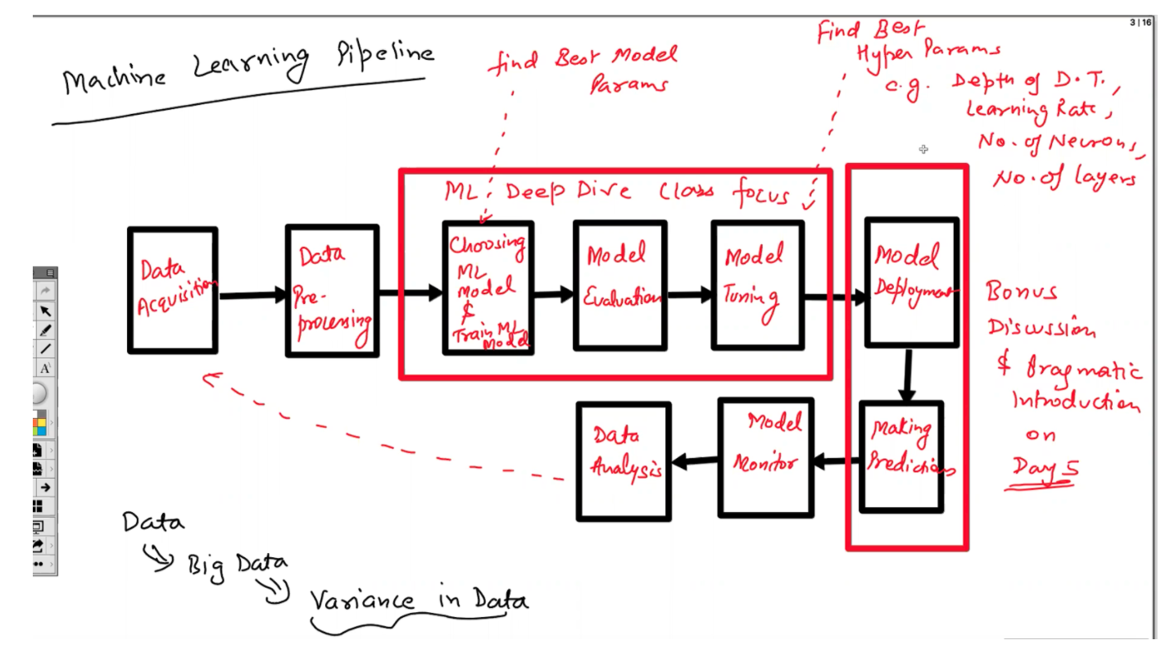

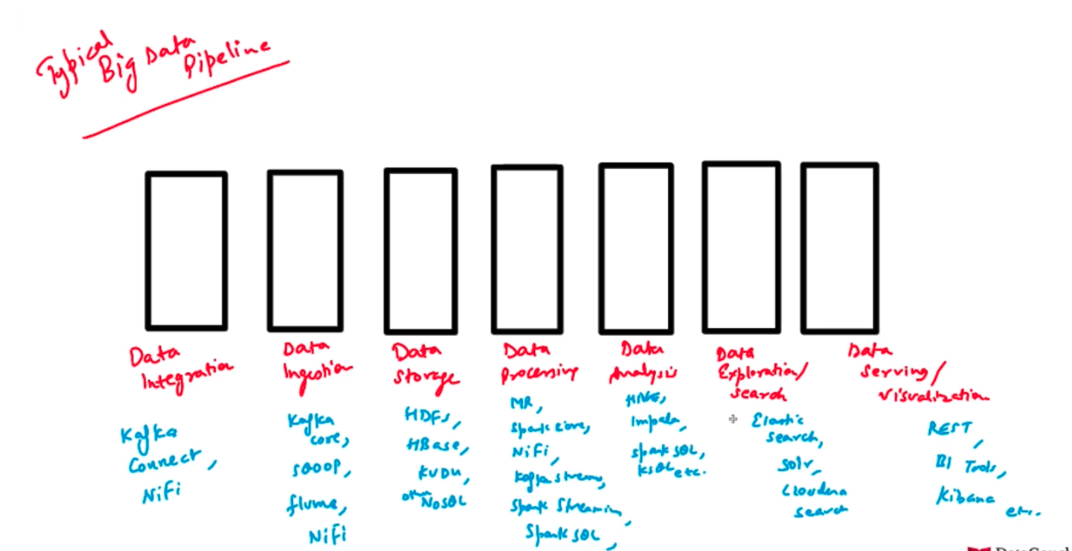

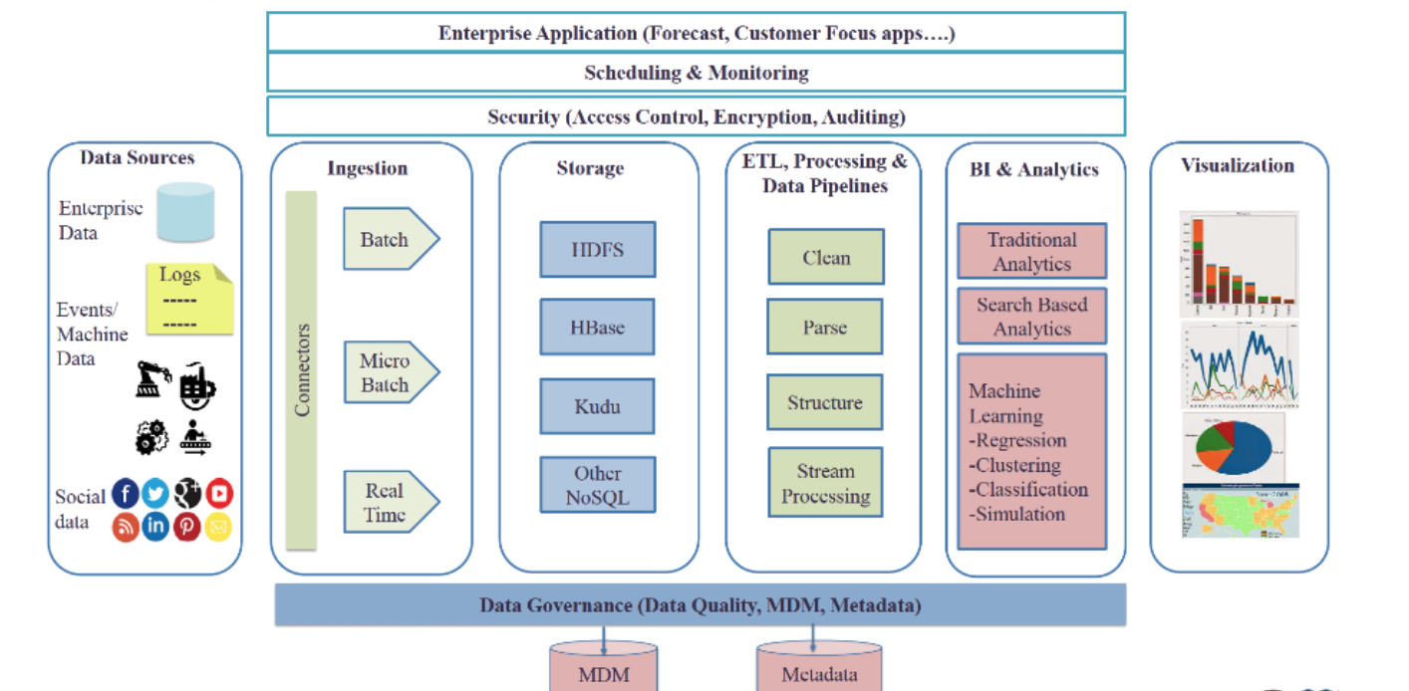

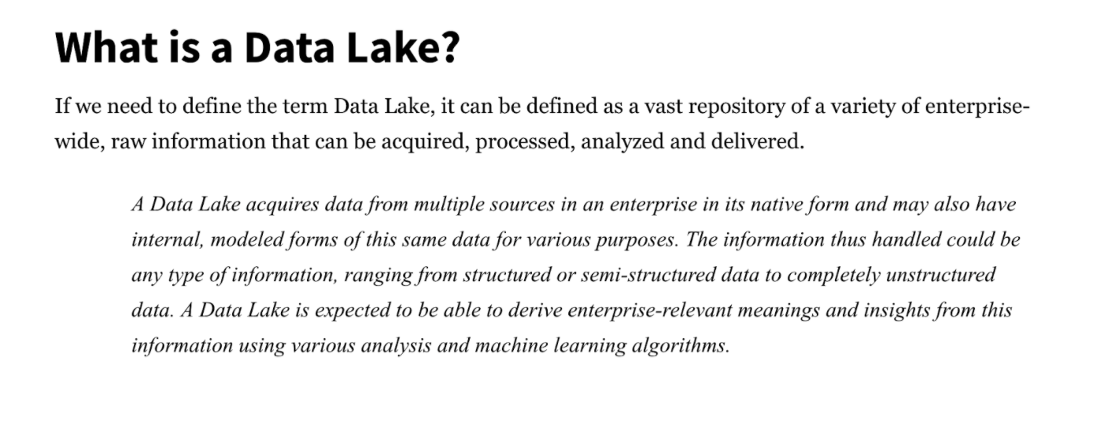

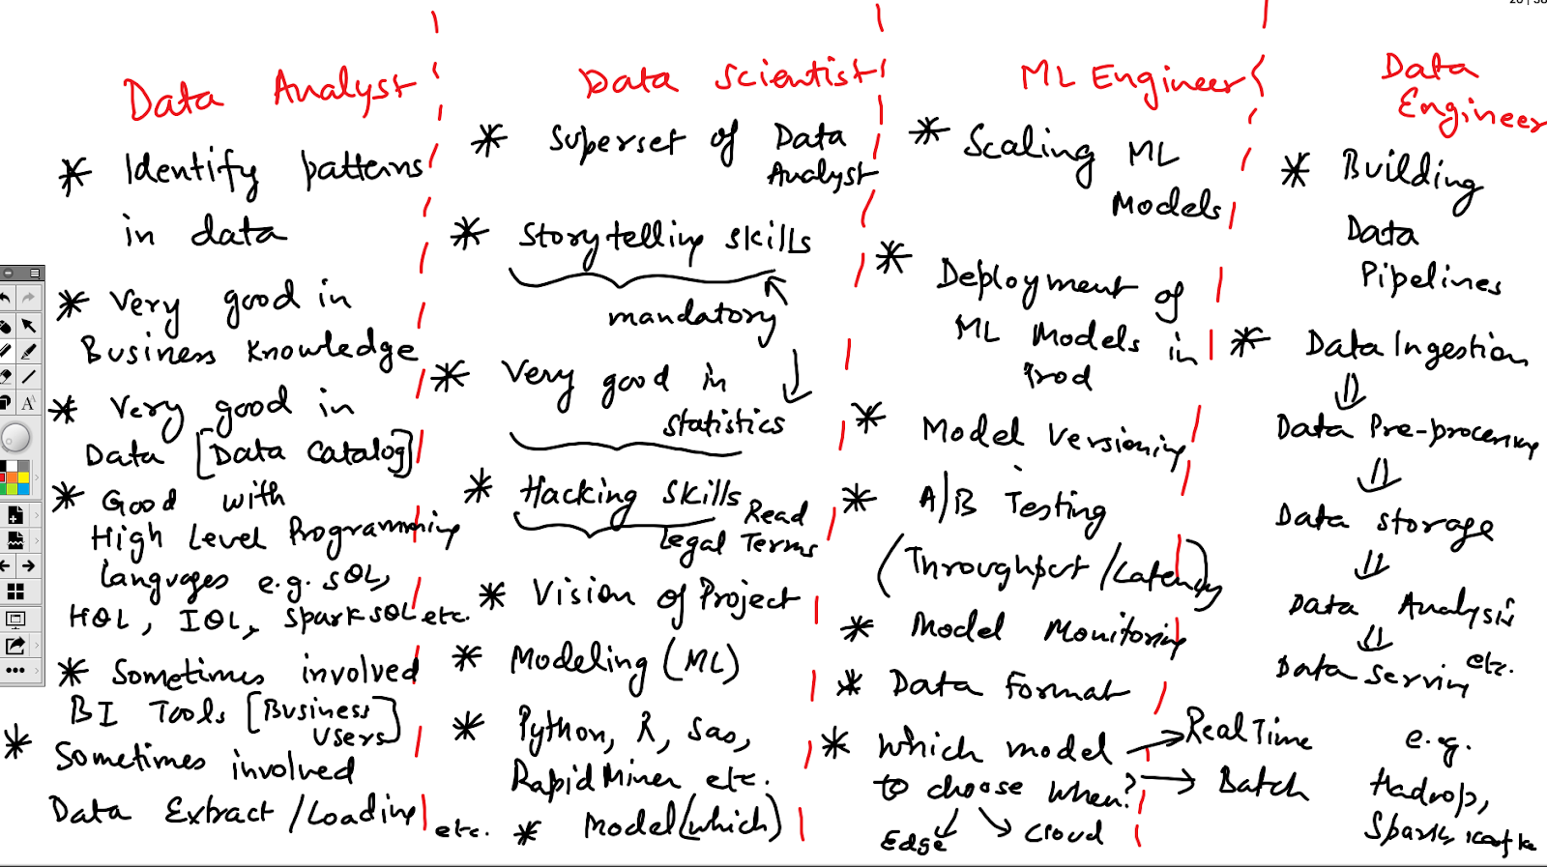

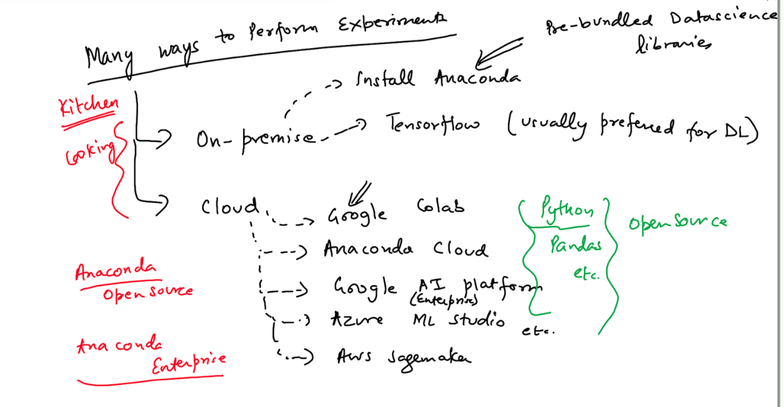

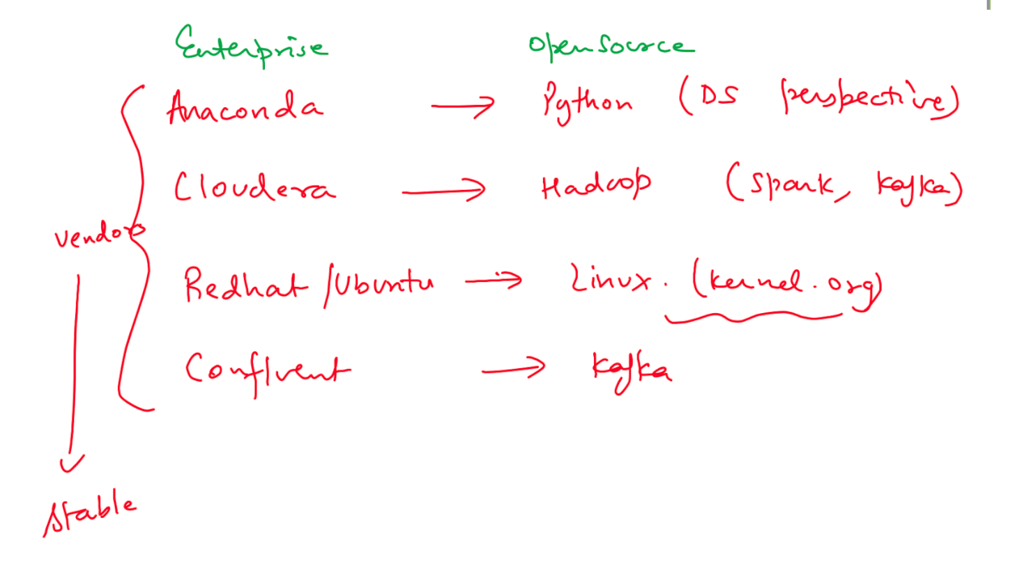

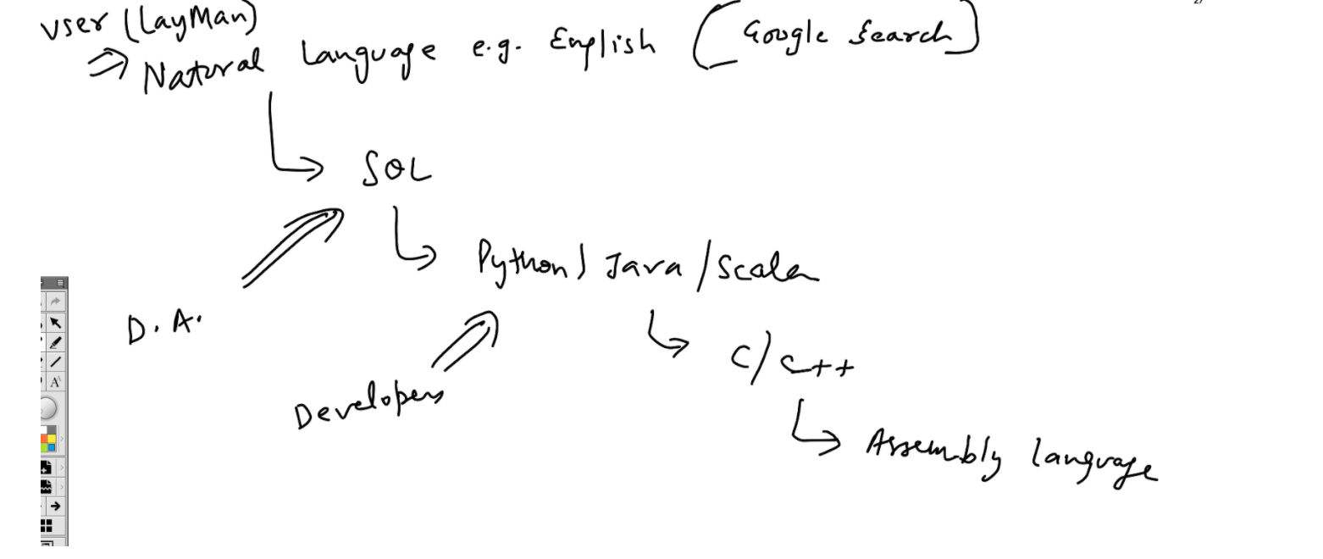

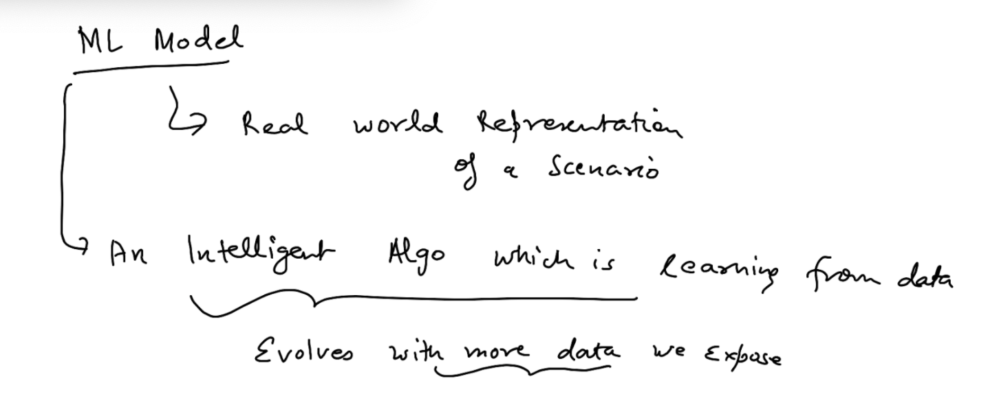

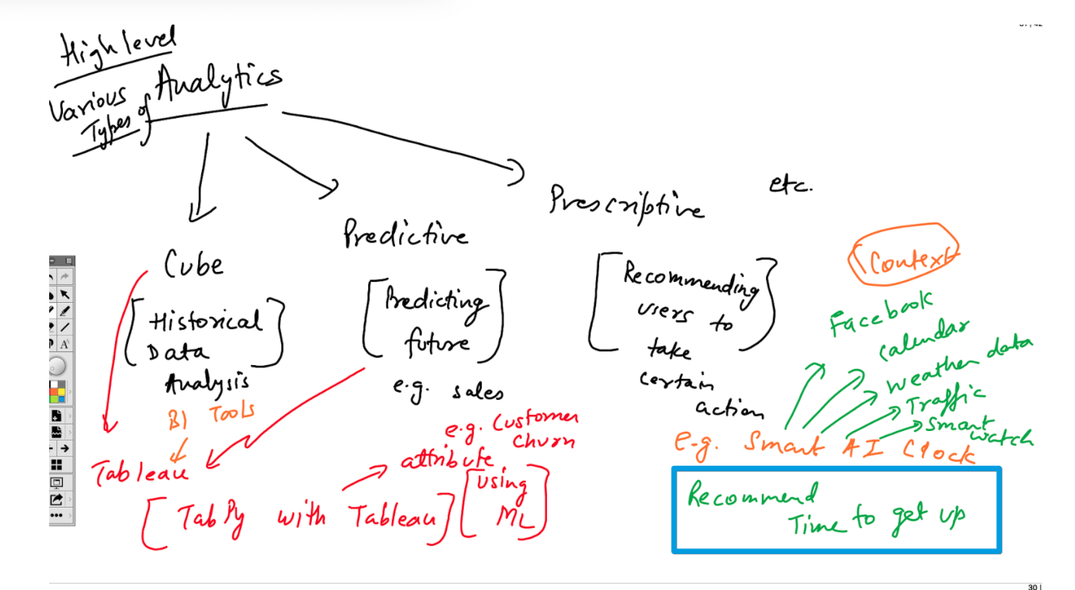

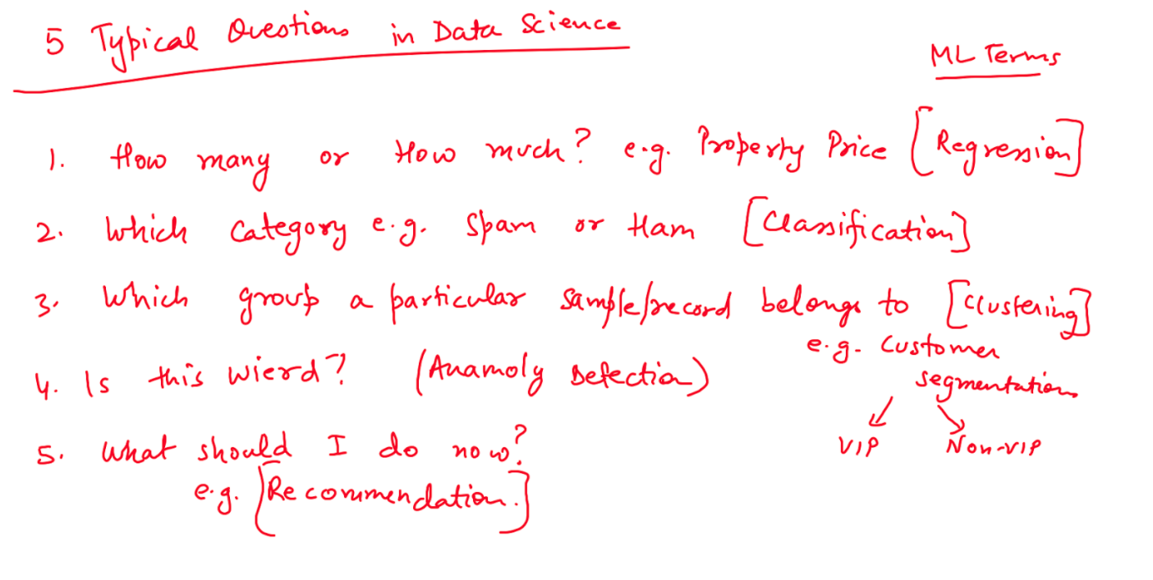

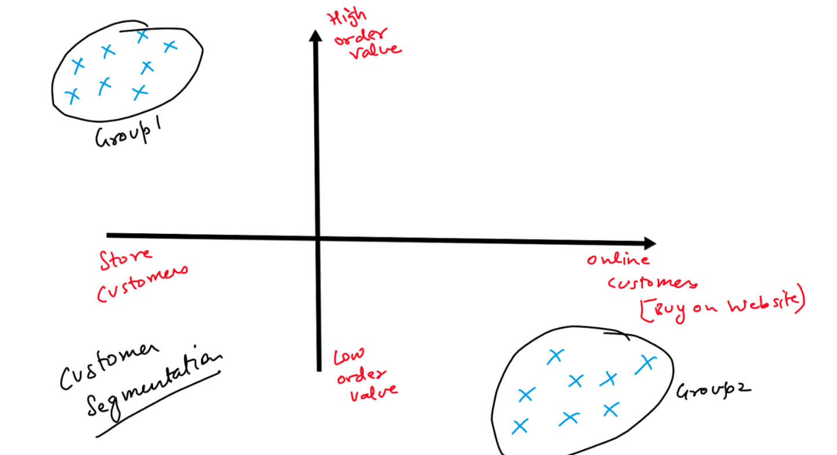

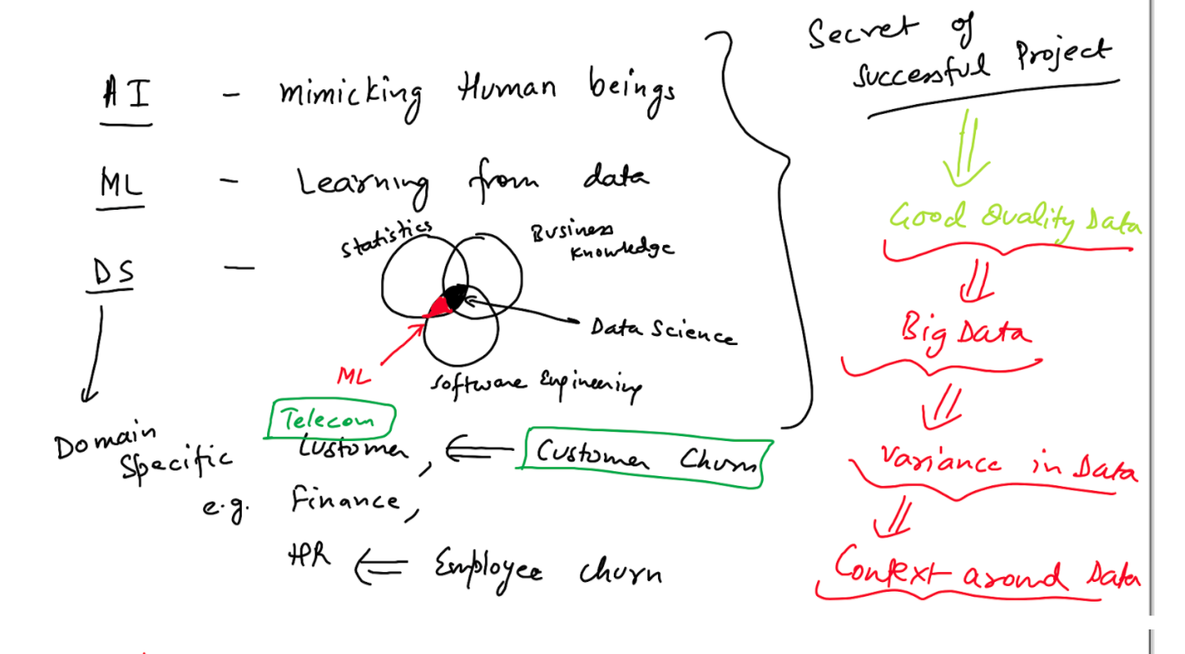

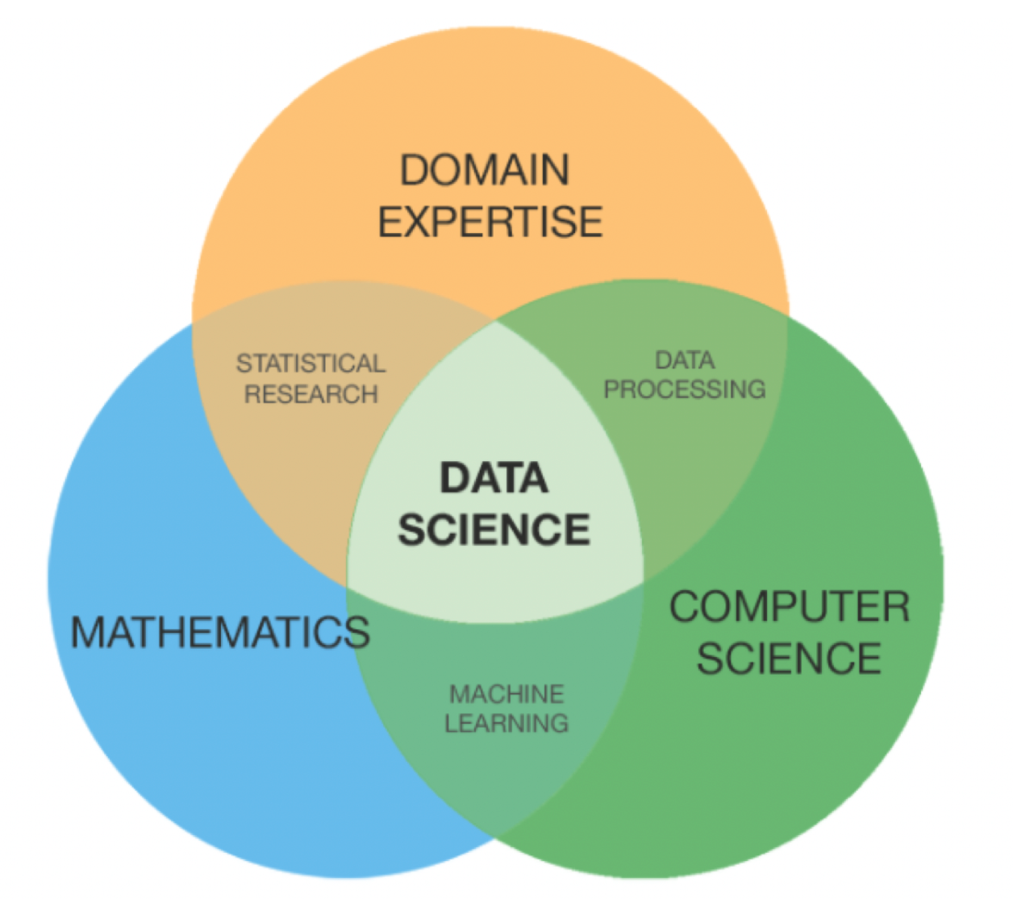

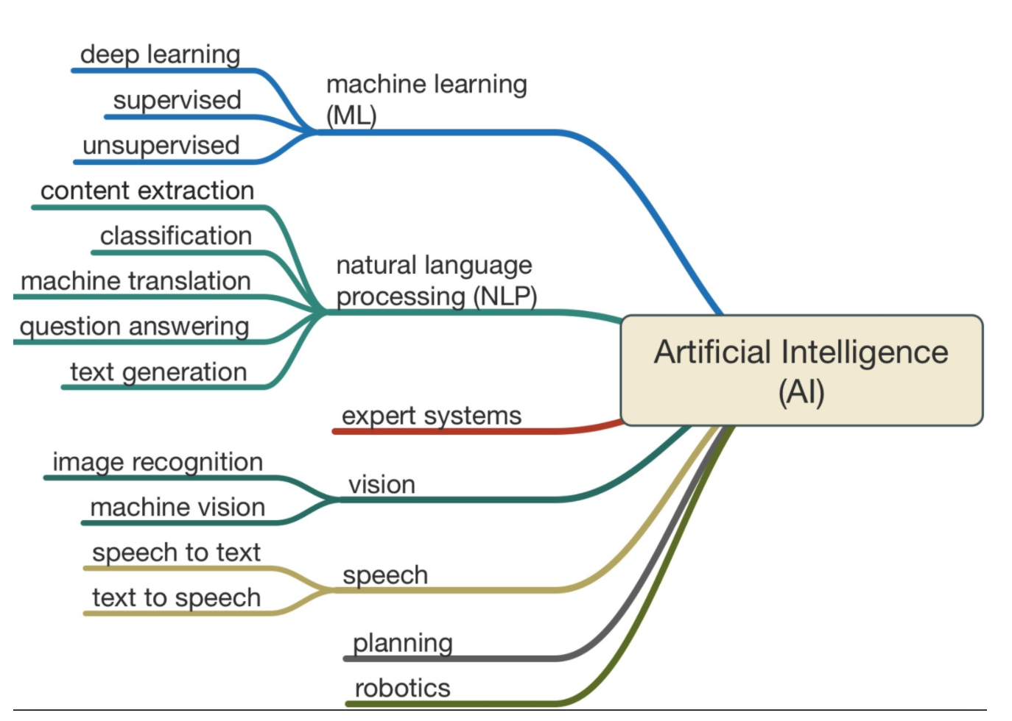

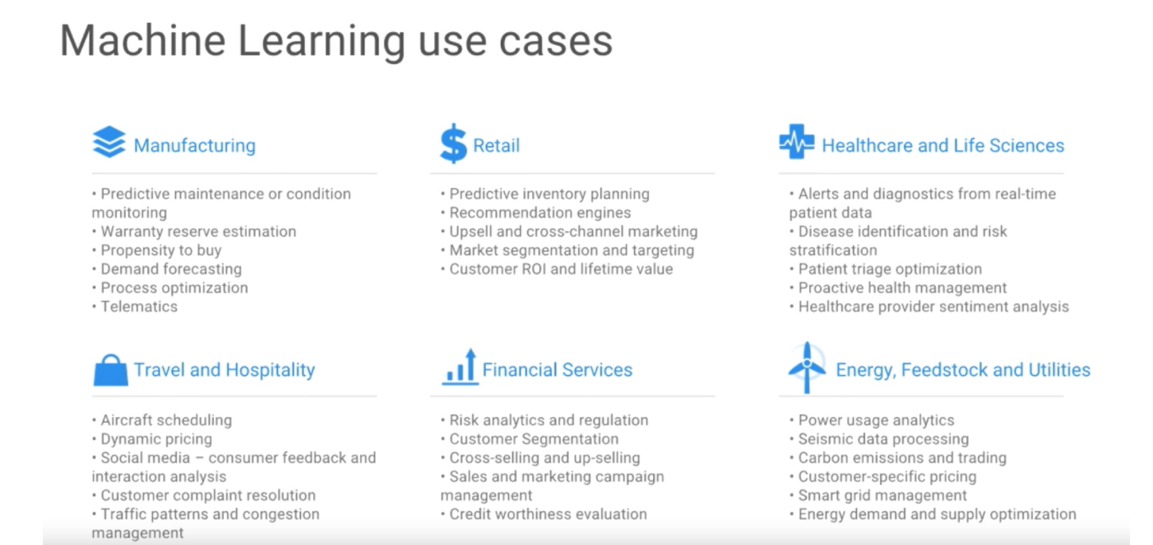

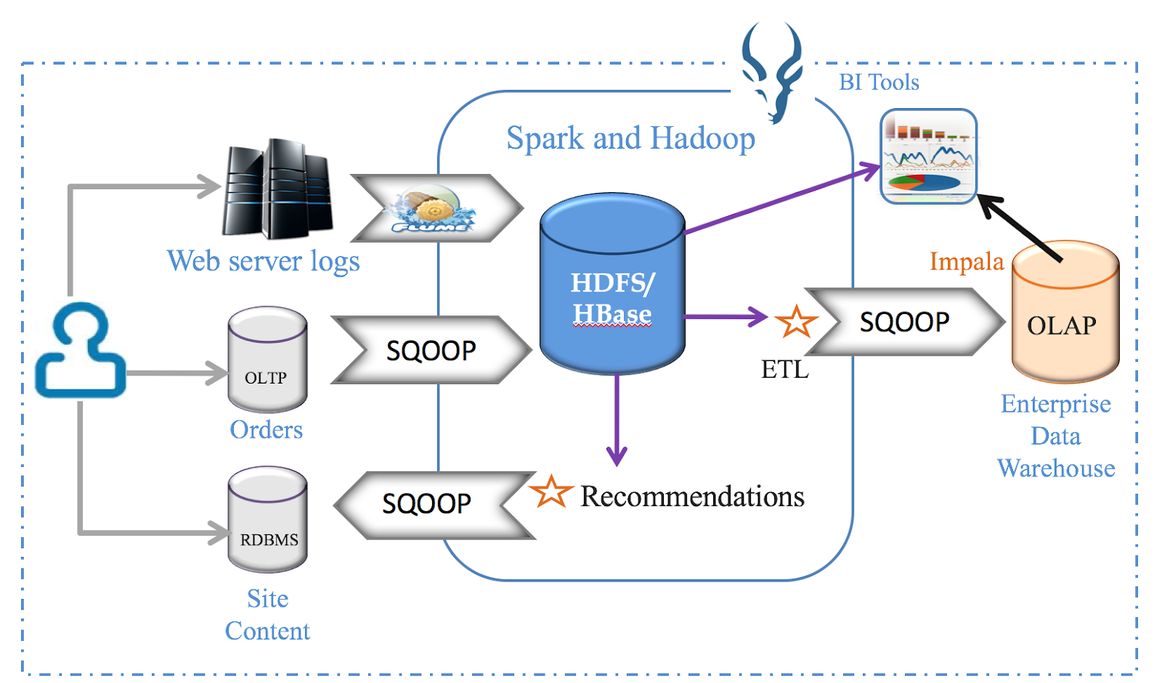

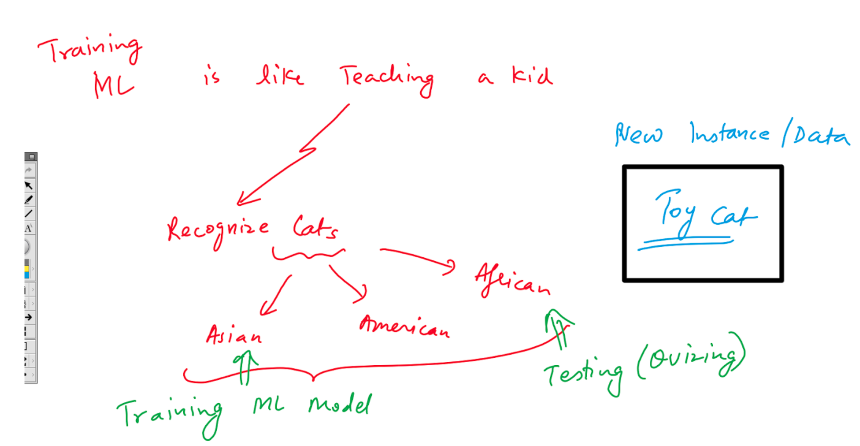

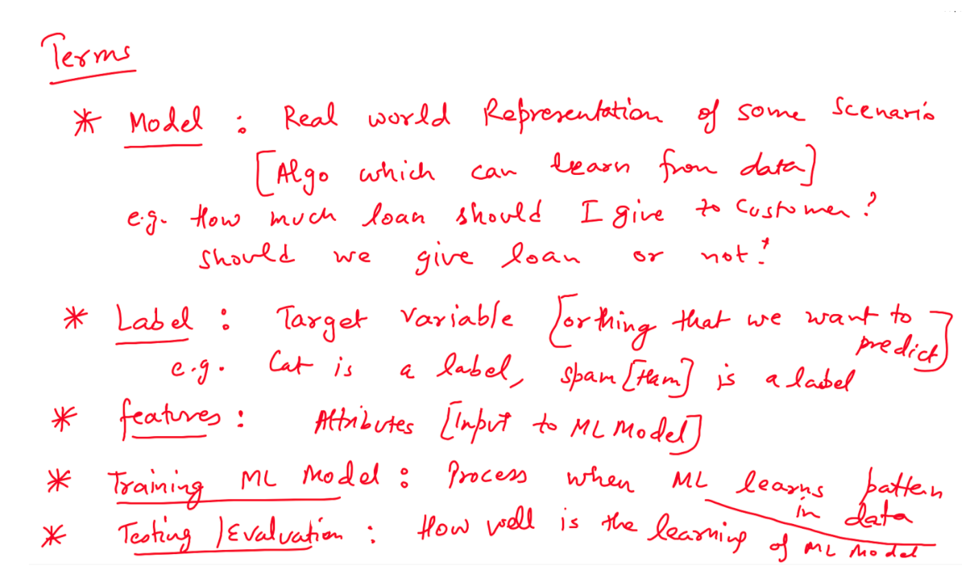

**Where ML should not be applied**

* Structured data where number of possibilities are limited.. Easy to capture to logic through conventional programming... can be defined with Rule based system e.g. eCommerce Application dealing with Order status
* 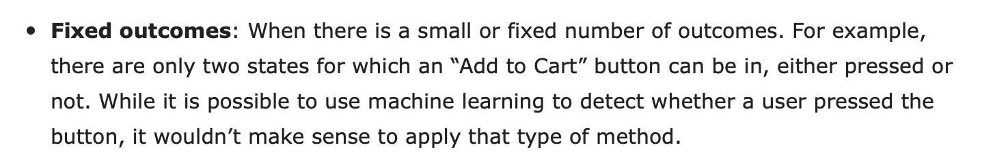
* Cost of implementing AI/ML is much more than manual implementation e.g. in US, cost of labour is very high compared to African countries
* When we have limited data for training a Machine learning
* Historical Data Analysis e.g. Cube Analytics

**Few Scenarios ML can be applied -**

* Novel scenarios e.g. Face Recognition, Detecting age/gender from Audio, Classifying/Detecting objects in pictures, Spam Detection etc.



* **Infinite possibilities in spelling mistakes.. Good candidate for ML**

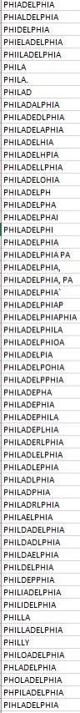

**More examples here -**

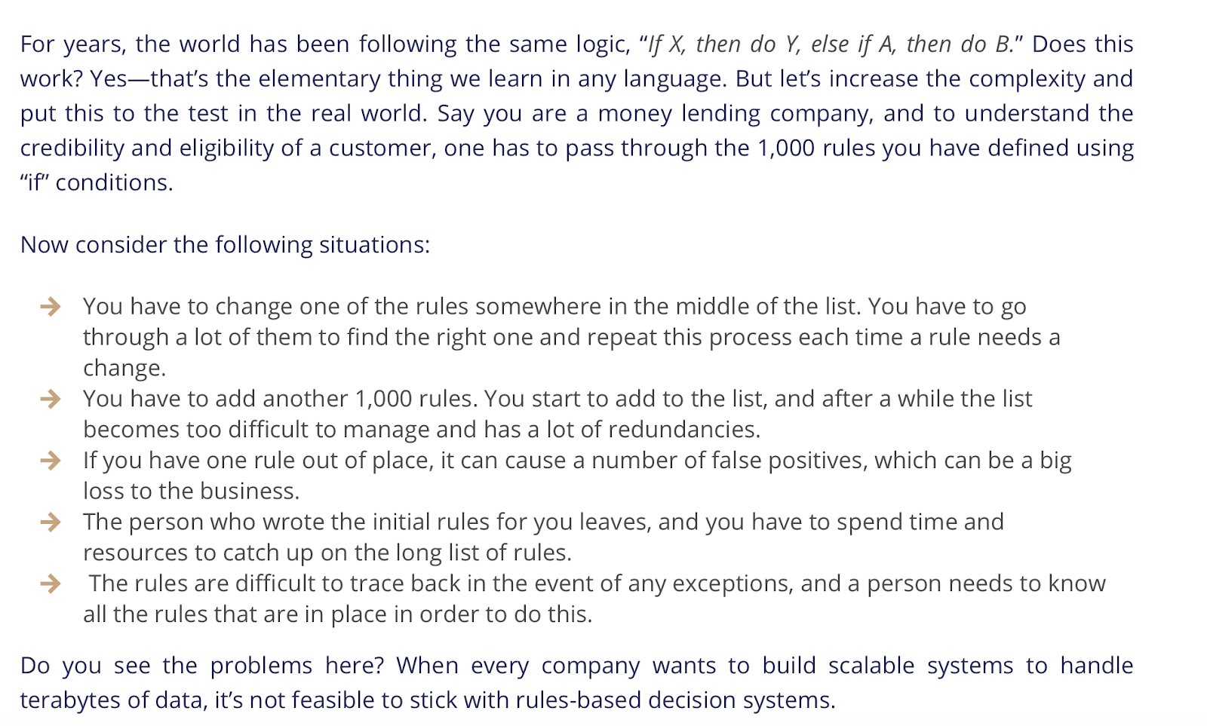

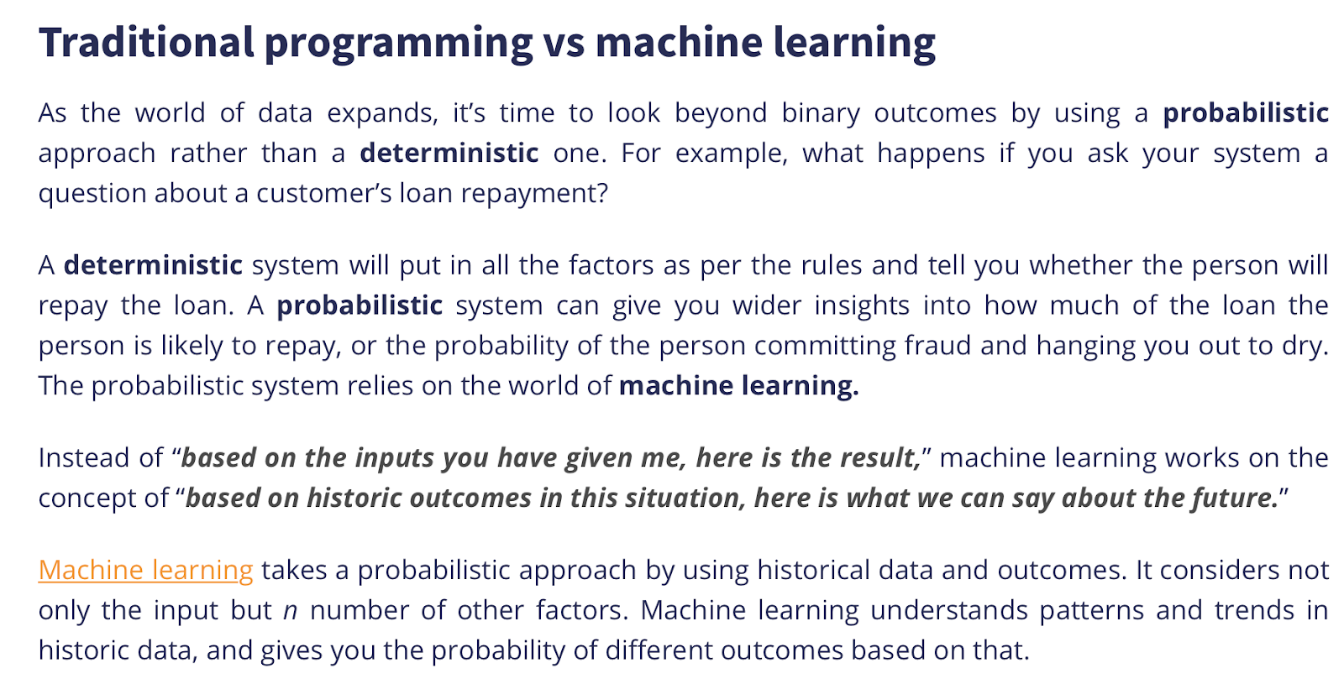

[**https://www.socure.com/blog/rules-are-meant-to-be-broken-machine-learning-vs.-rules-based-systems**](https://www.socure.com/blog/rules-are-meant-to-be-broken-machine-learning-vs.-rules-based-systems)

[**https://www.nice.com/rpa/rpa-guide/what-is-cognitive-rpa/#:~:text=Cognitive%20RPA%20takes%20things%20a,%2C%20less%20rule%2Dbased%20tasks.**](https://www.nice.com/rpa/rpa-guide/what-is-cognitive-rpa/#:~:text=Cognitive%20RPA%20takes%20things%20a,%2C%20less%20rule%2Dbased%20tasks.)

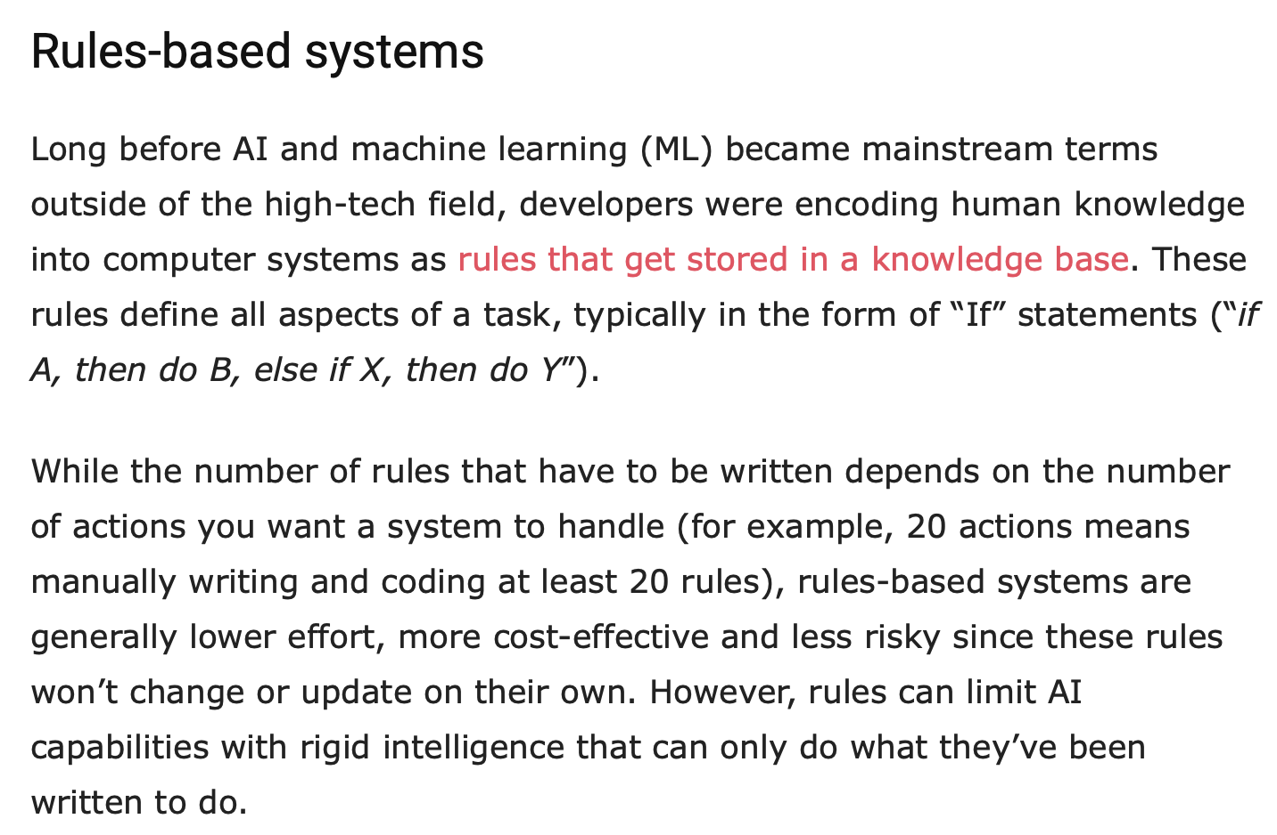

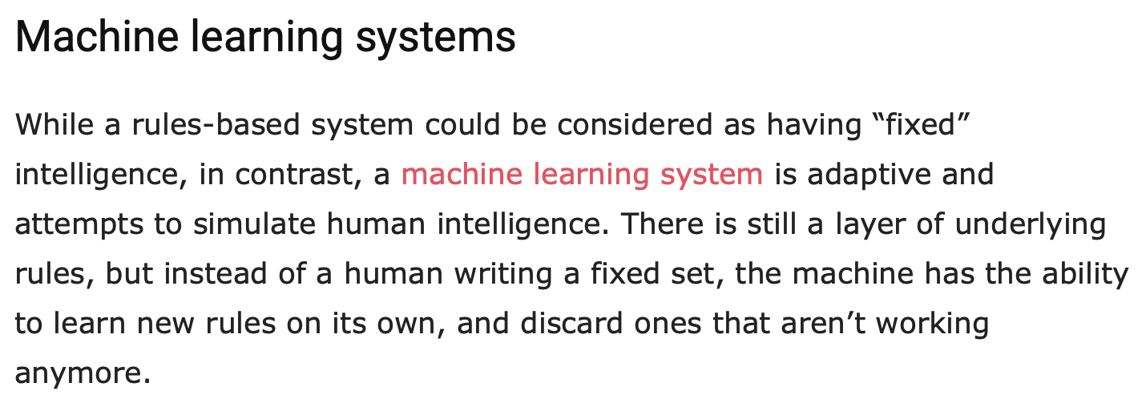

**https://bdtechtalks.com/2020/06/05/rule-based-ai-vs-machine-learning/**

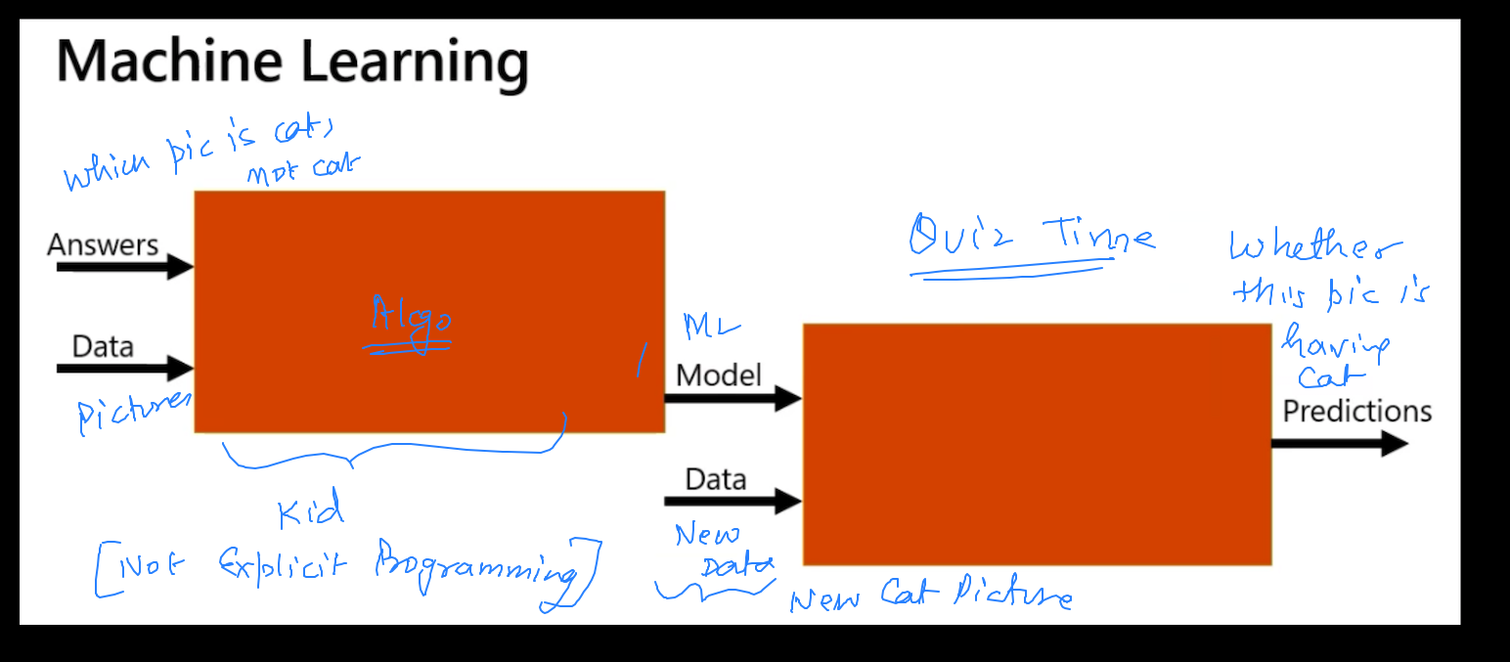

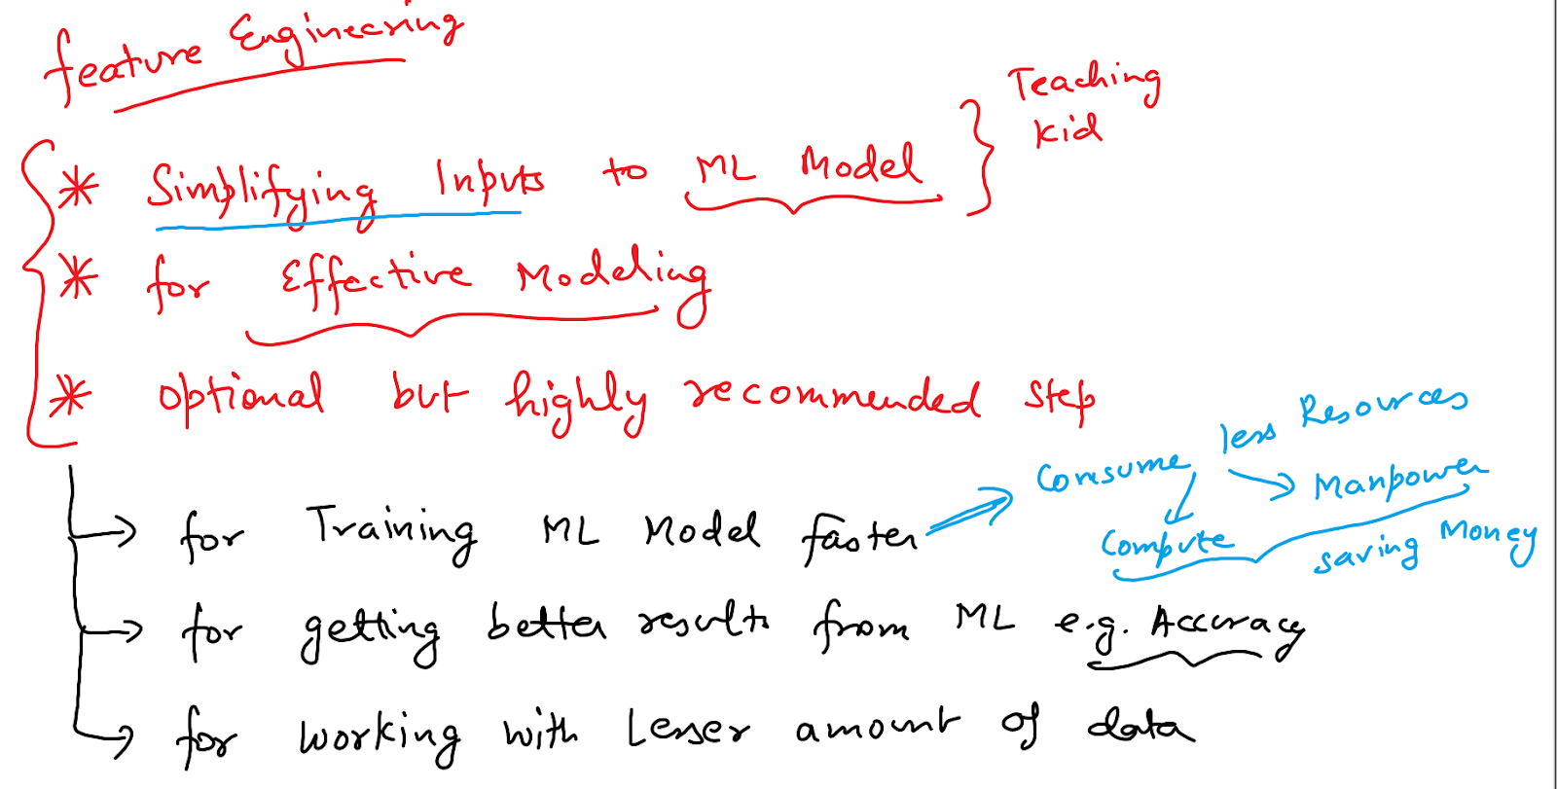

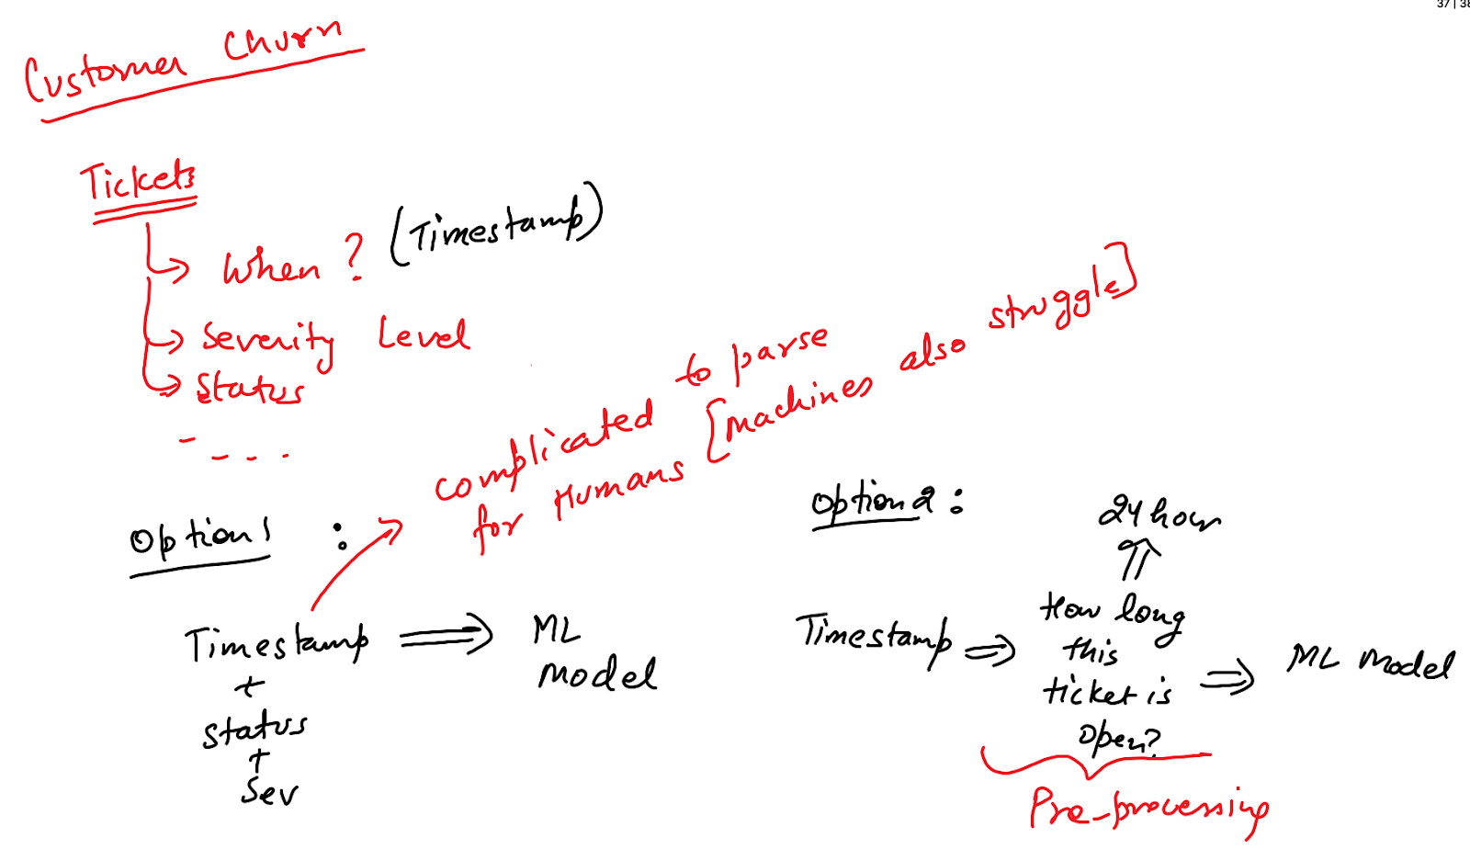

**Day 2: Just Enough Python**

**How to upload data to Colab from Local FS -**

**from google.colab import files**

**uploaded = files.upload()**

**for fn in uploaded.keys():**

**print('User uploaded file "{name}" with length {length} bytes'.format(**

**name=fn, length=len(uploaded[fn])))**

**Working with Conda Environment -**

<https://docs.conda.io/projects/conda/en/latest/user-guide/tasks/manage-environments.html>

***sudo conda create --name mltraining***

***conda activate mltraining***

***conda remove --name mltraining --all***

***conda env list***

***sudo rm /Users/bhavuk/opt/anaconda3/envs/demotraining/conda-meta/history***

***sudo conda install -c conda-forge xgboost***

***sudo conda remove xgboost***

***IP Address Parsing***

***\[(\d{1,3}\.){3}(\d{1,3})\]***

<https://docs.microsoft.com/en-us/azure/machine-learning/team-data-science-process/overview>

<https://ai.google/principles/>

ML Biasness

<https://www.youtube.com/watch?v=59bMh59JQDo>

<https://www.sharper.ai/ai-is-the-new-electricity/>

<https://www.regexpal.com/>

<https://www.debuggex.com/cheatsheet/regex/python>

The problem with AI is not AI -

<https://papers.nips.cc/paper/5656-hidden-technical-debt-in-machine-learning-systems.pdf>

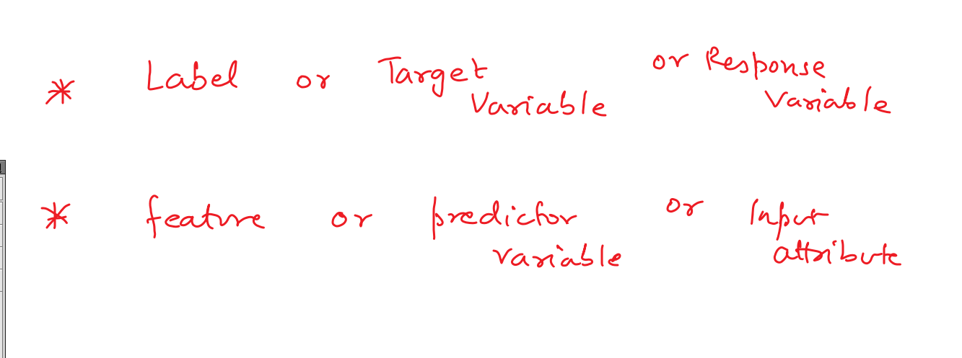

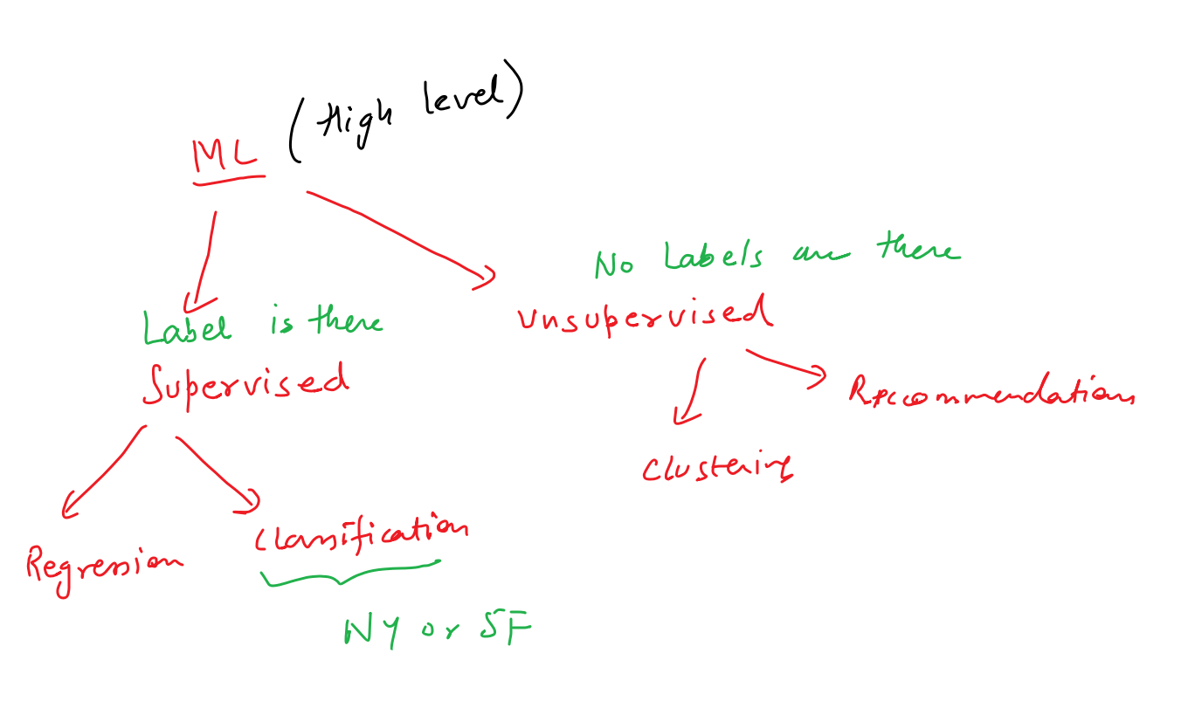

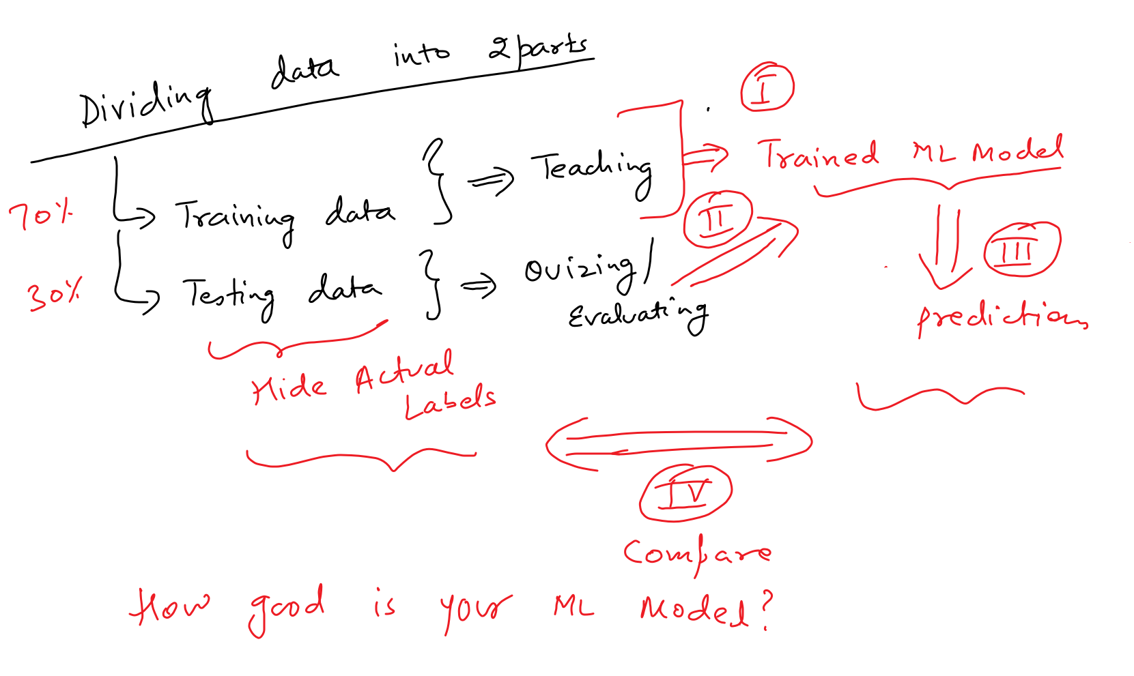

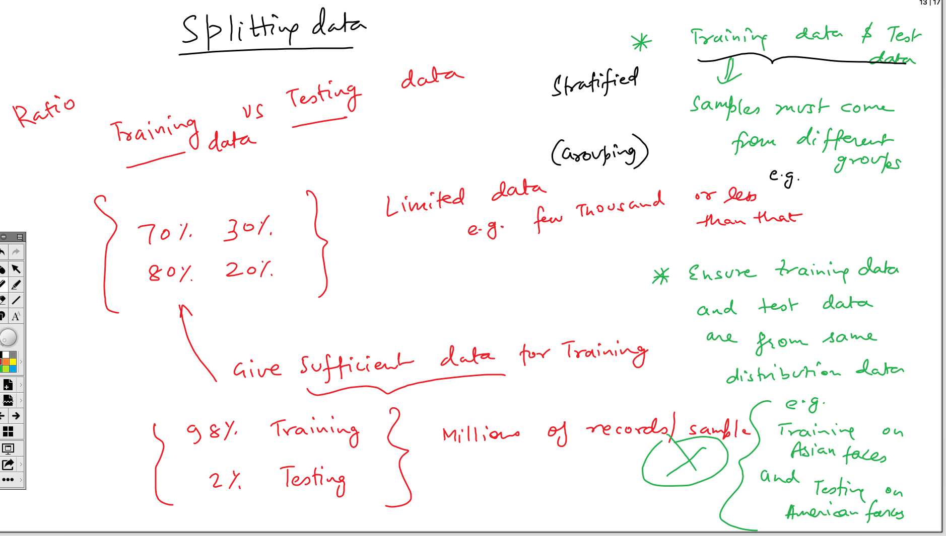

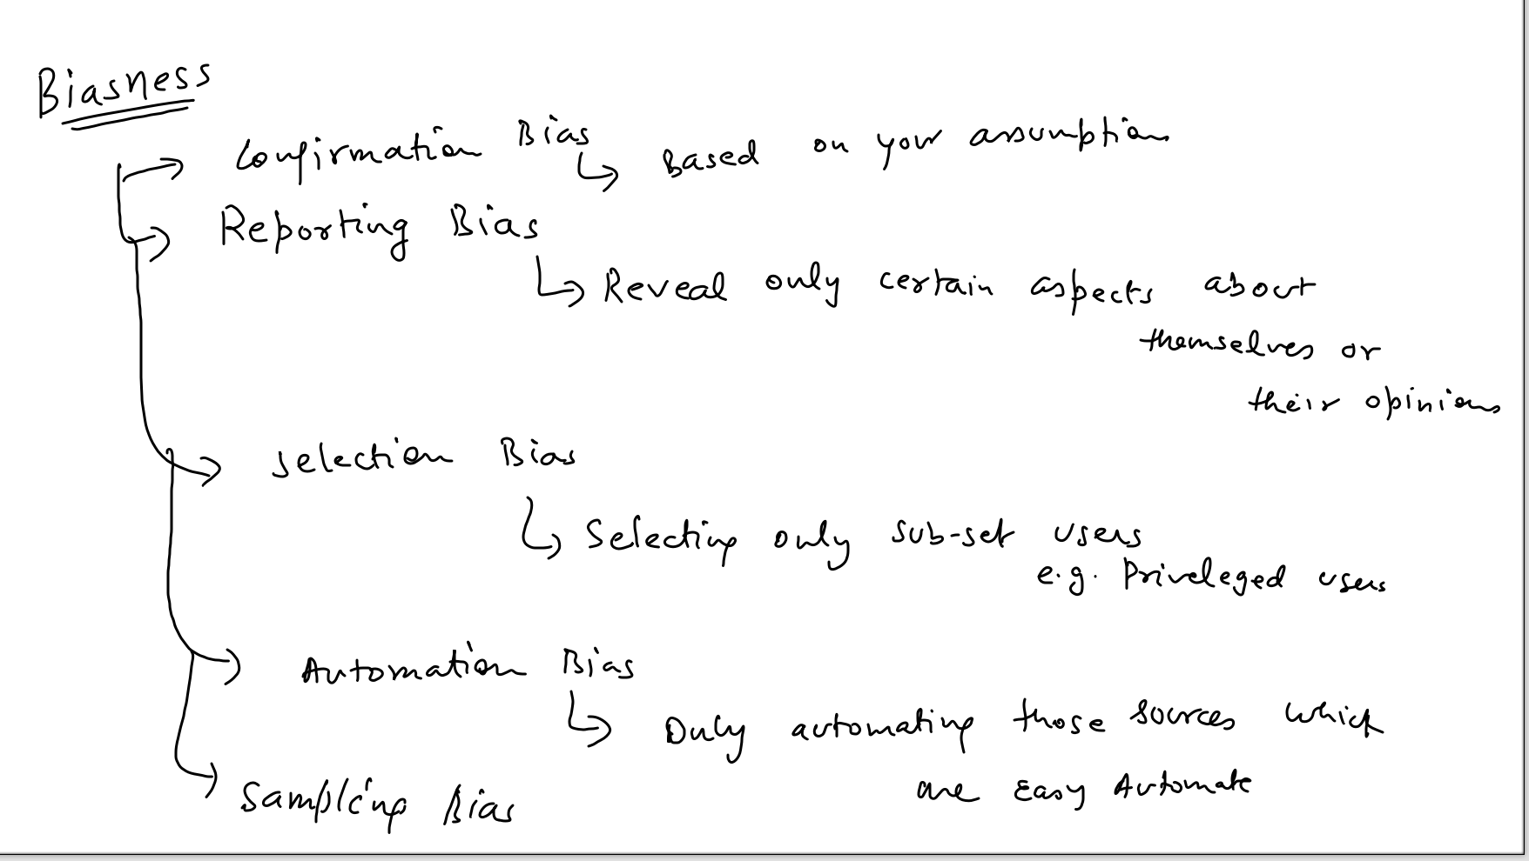

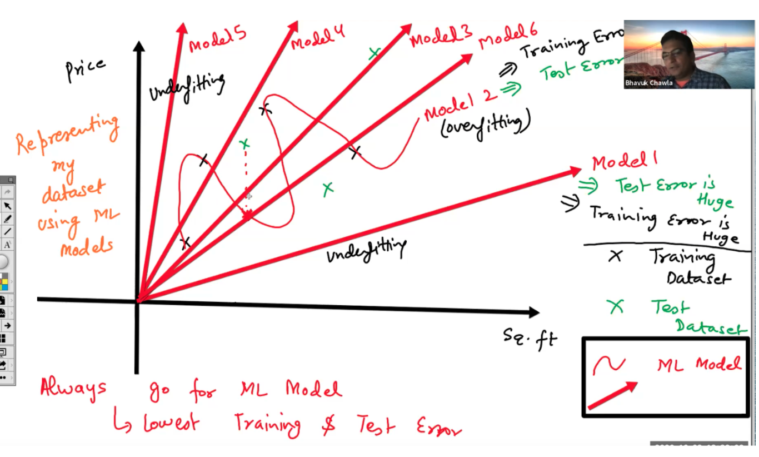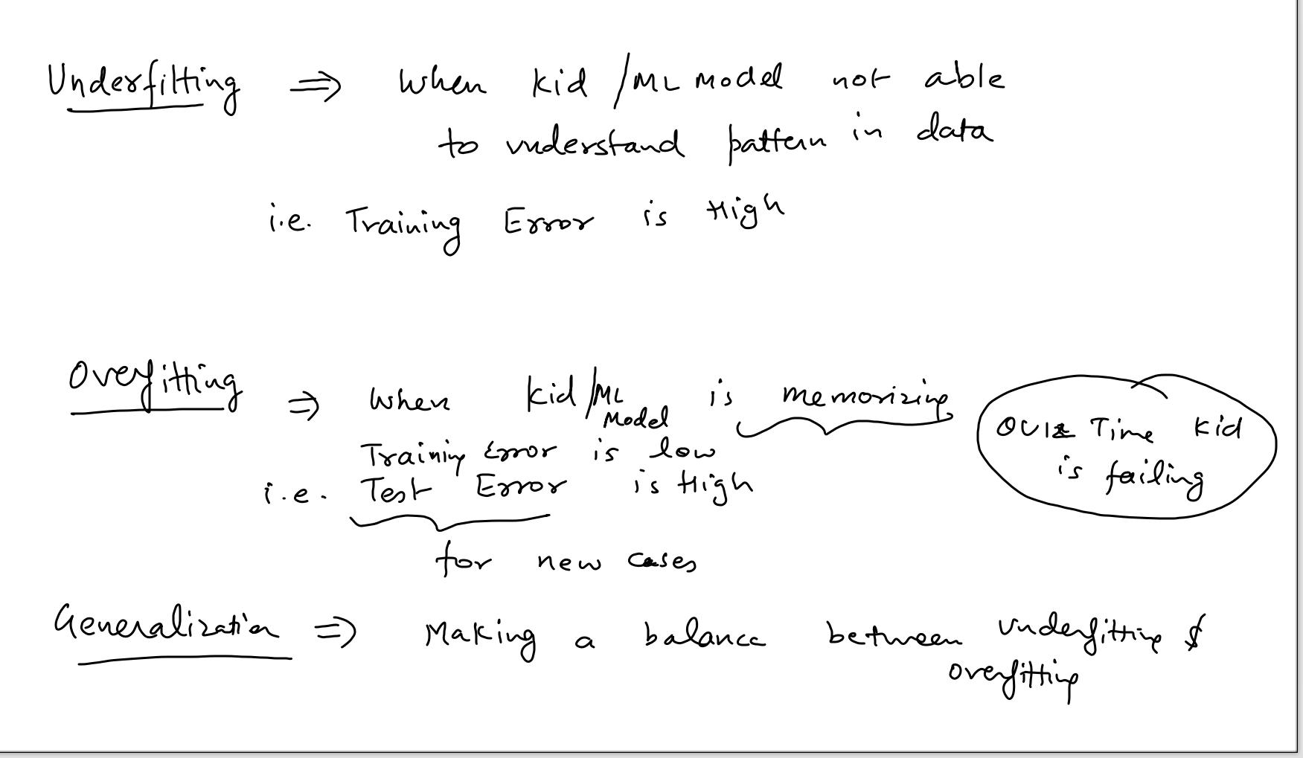

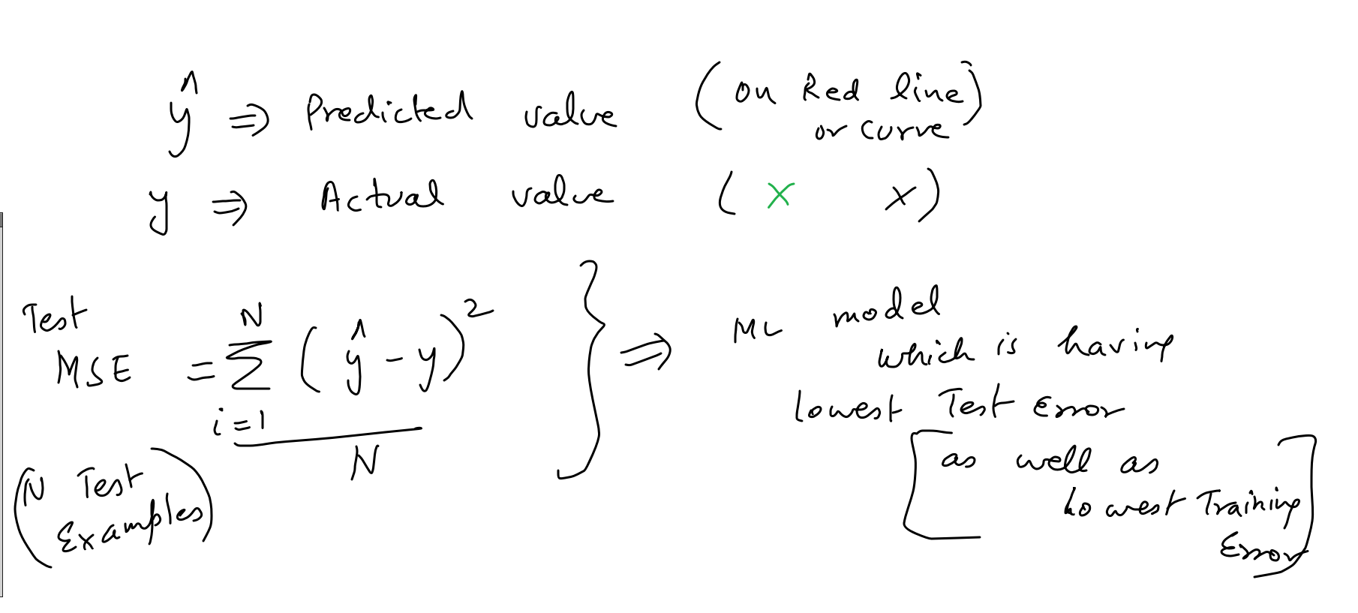

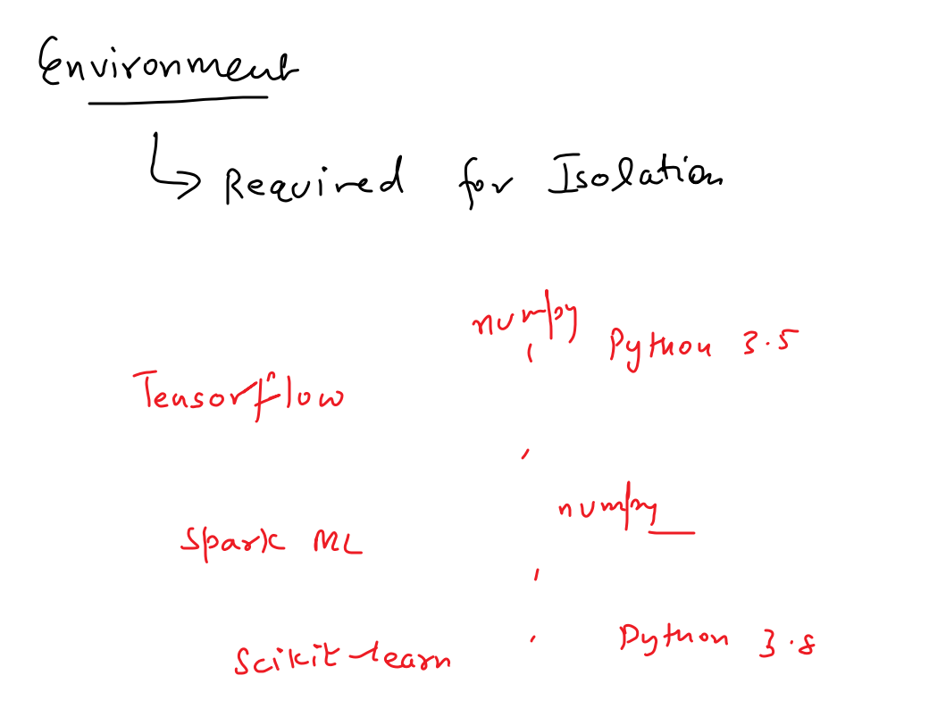

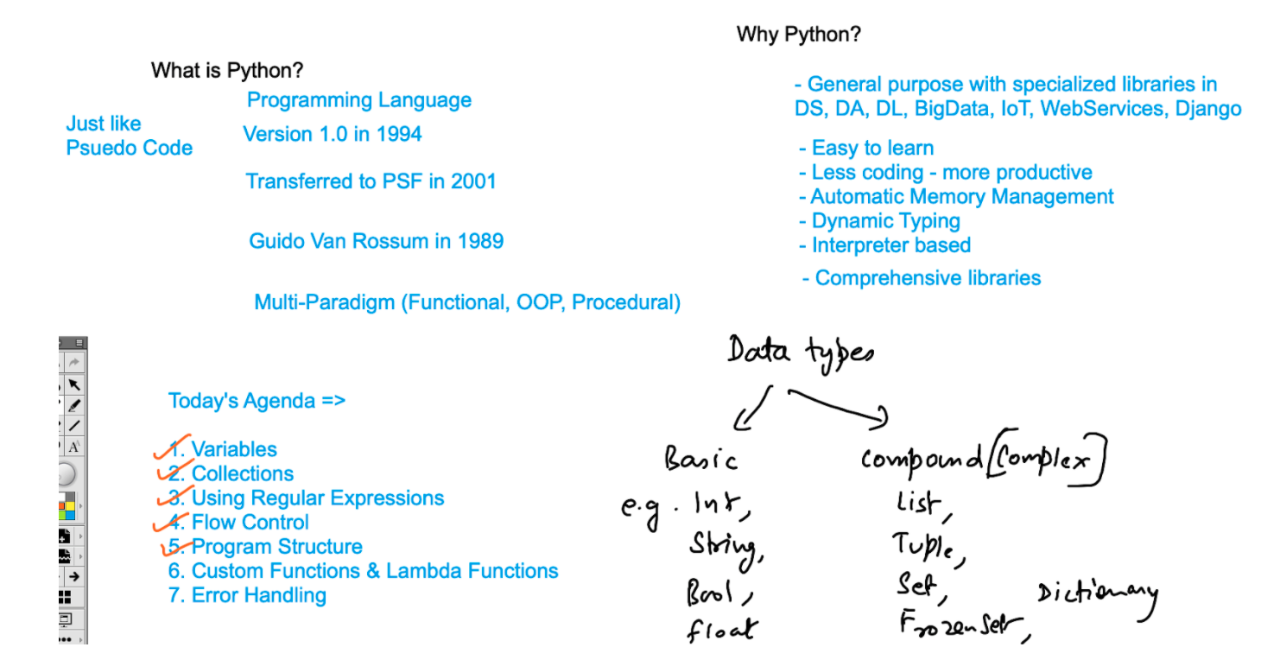

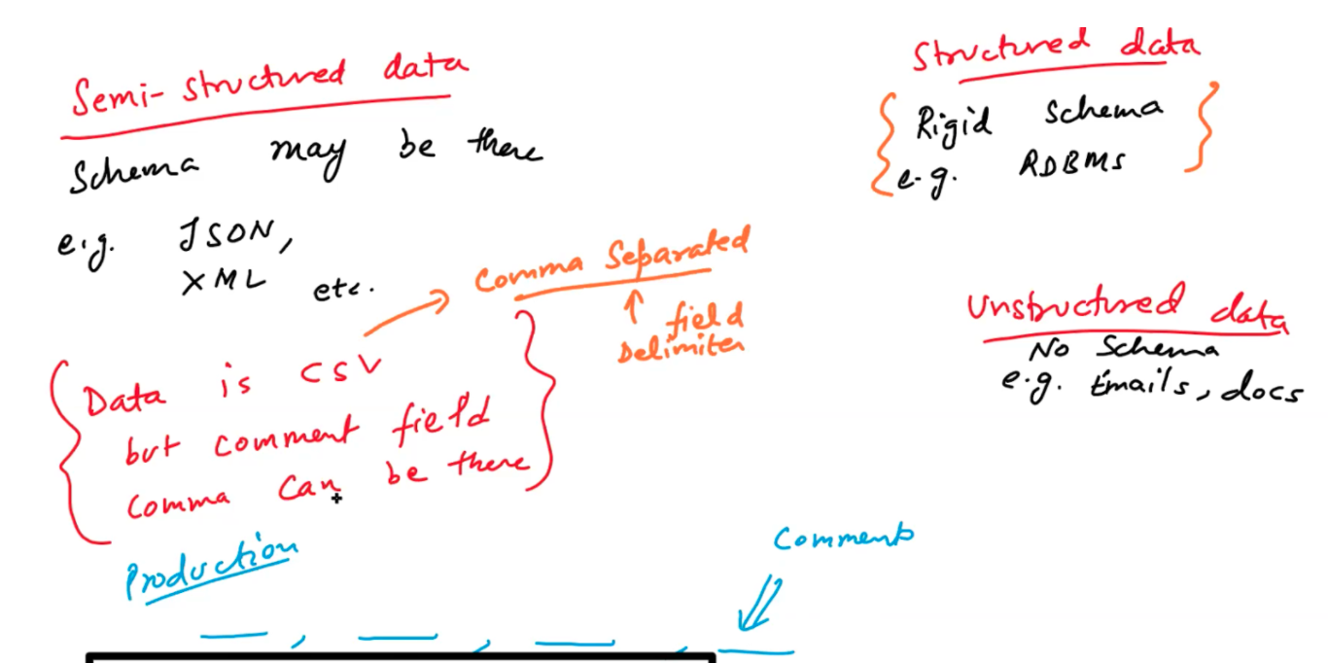

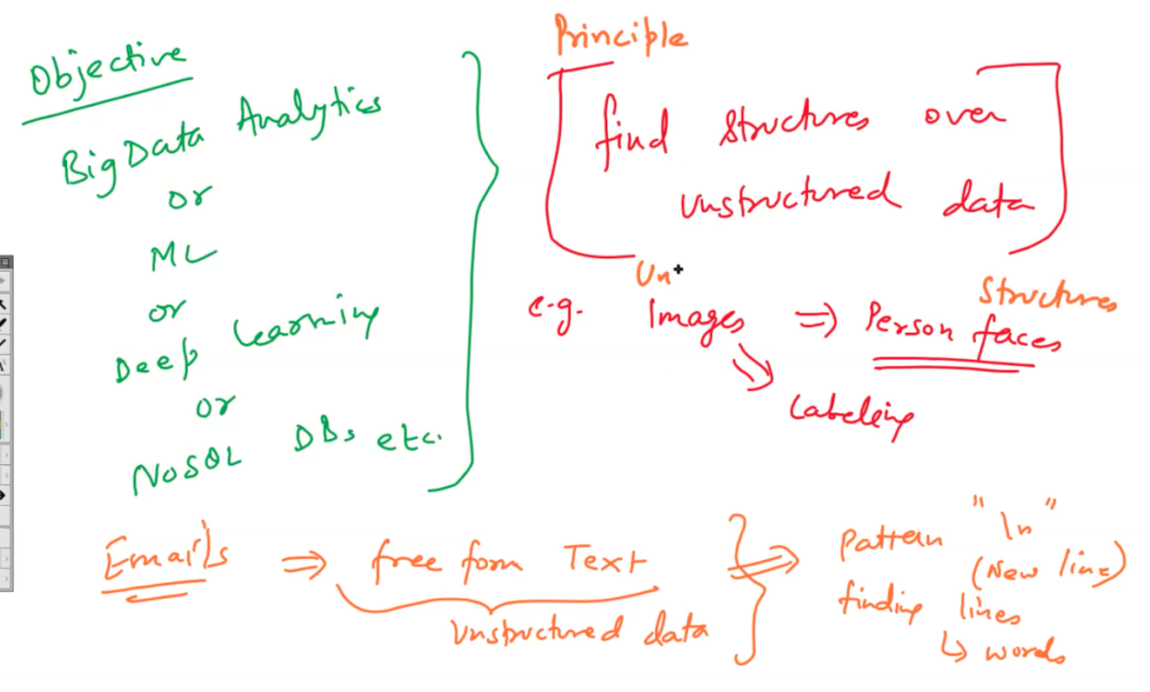

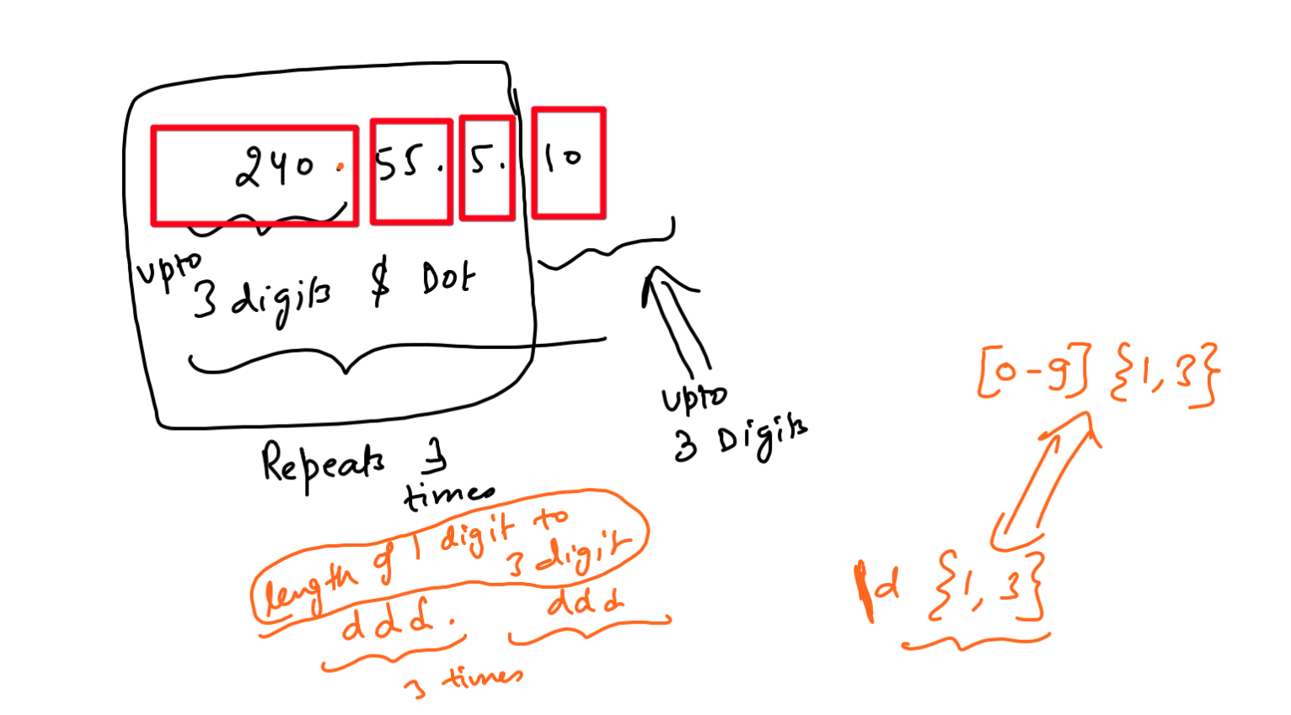

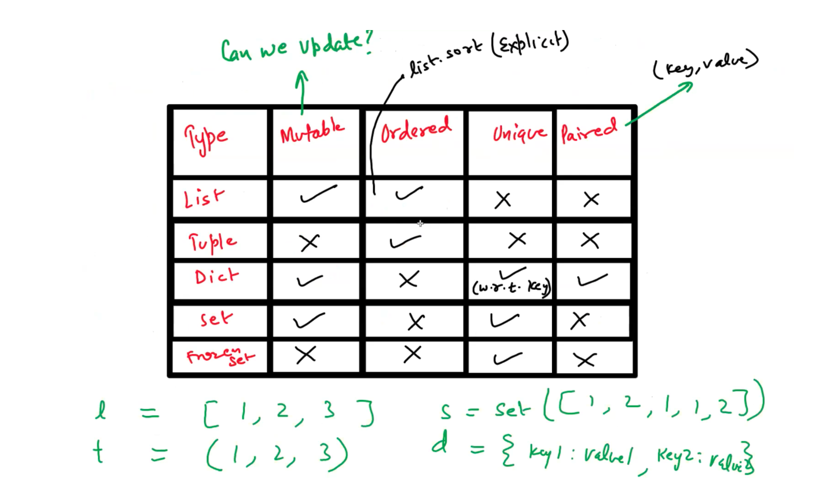

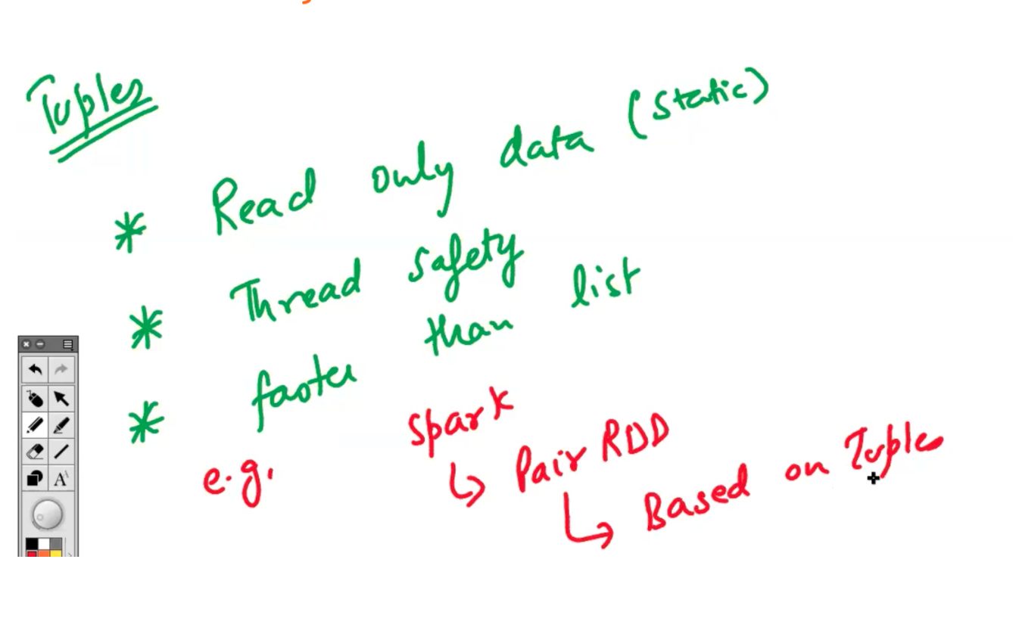

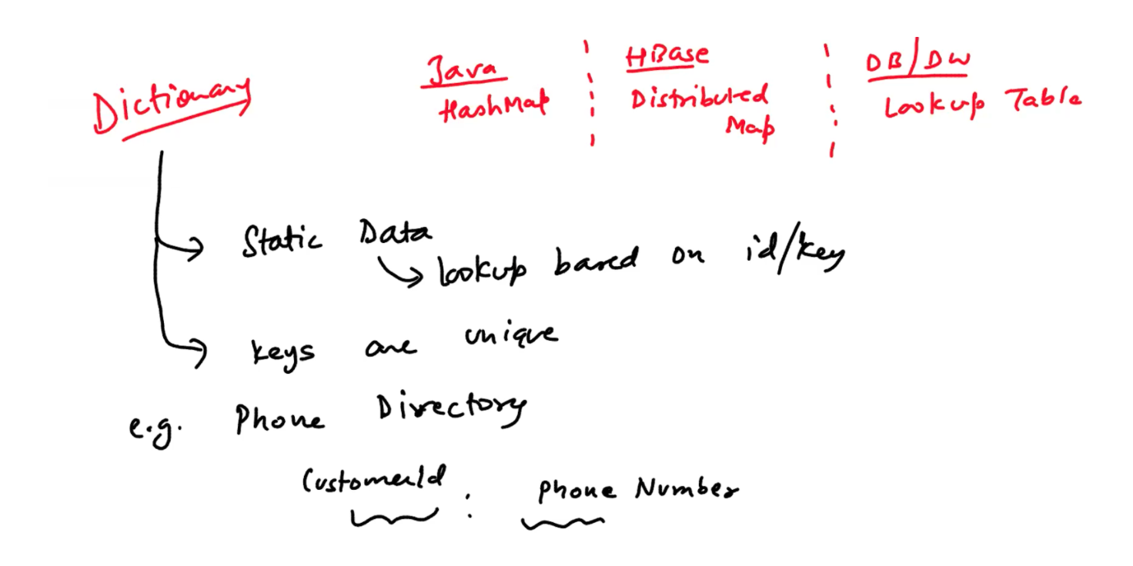

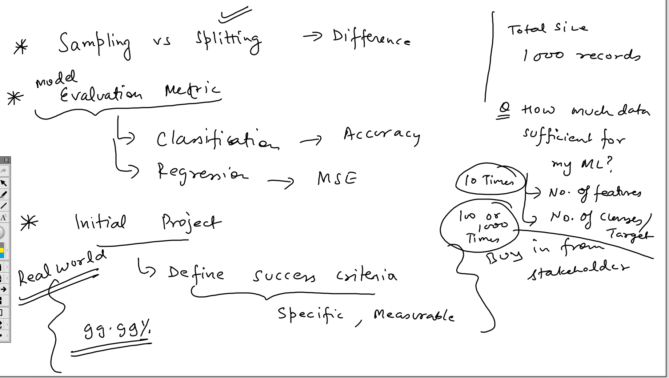

**Day 3: Data Processing and Analysis using Pandas**

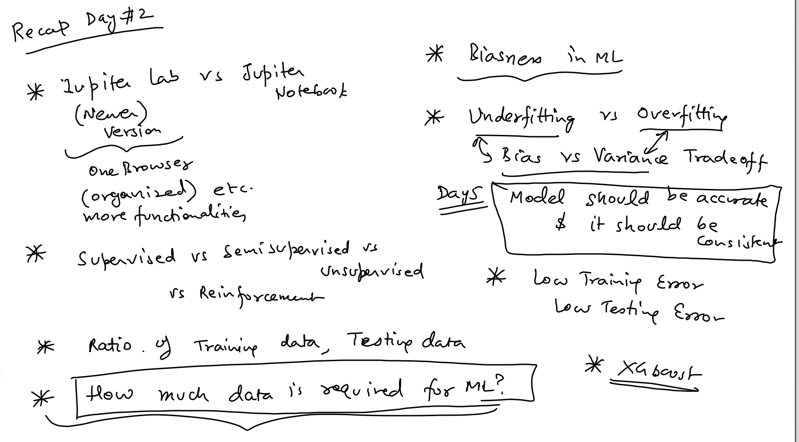

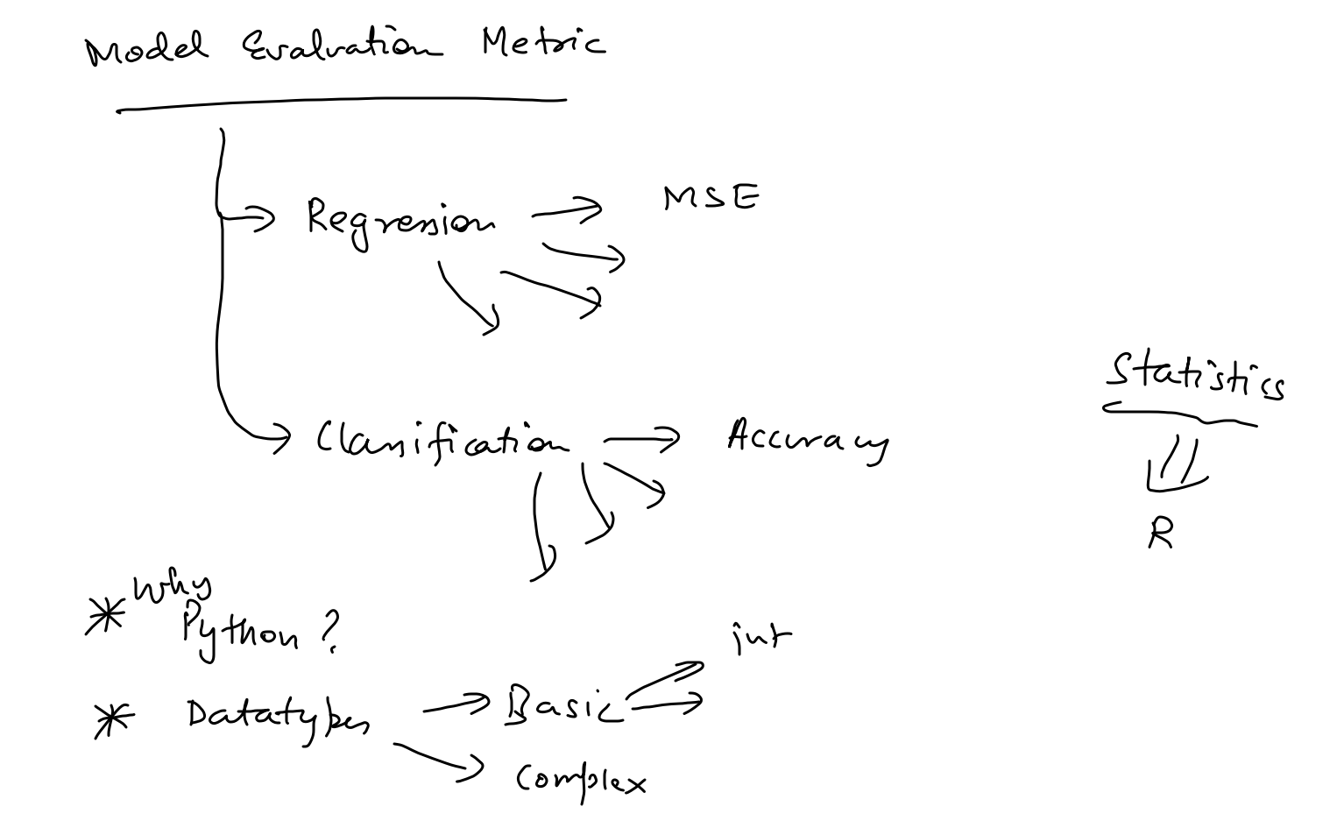

<https://pandas.pydata.org/Pandas_Cheat_Sheet.pdf>

<https://bedford-computing.co.uk/learning/wp-content/uploads/2015/10/Python-for-Data-Analysis.pdf>

<https://tanthiamhuat.files.wordpress.com/2018/04/pythondatasciencehandbook.pdf>

Link to All Demo Notebooks

<https://drive.google.com/drive/folders/1ubFS8s7V1GIZI8syzHGu5fAd1yfQzJIs?usp=sharing>

**Python basics videos (19 videos) in my own language -**

<https://youtu.be/-6aGAnXy-vA>

**Pandas qcut vs cut for binning data -**

<https://pbpython.com/pandas-qcut-cut.html>

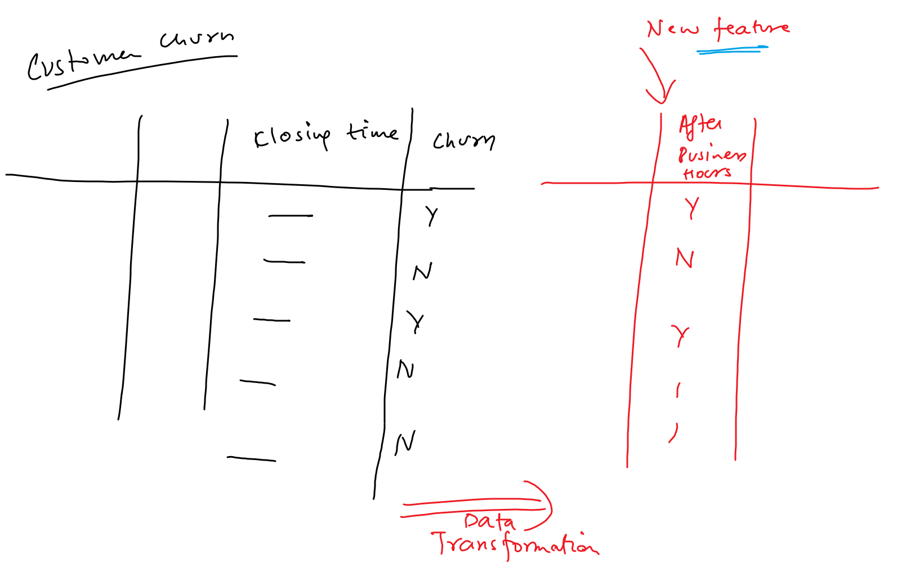

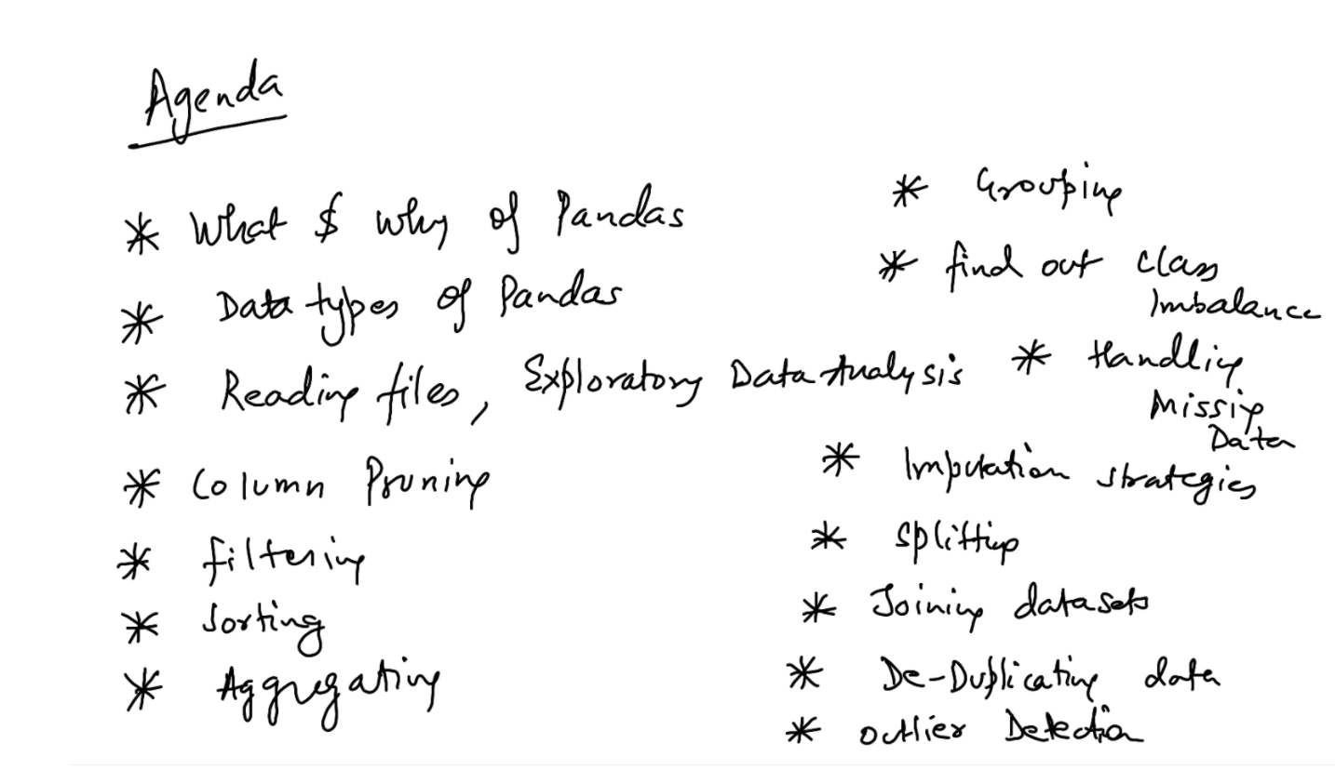

**NumPy's arrays** are more compact than Python lists -- a list of lists as you describe, in Python, would take at least 20 MB or so, while a NumPy 3D array with single-precision floats in the cells would fit in 4 MB. Access in reading and writing items is also faster with NumPy.

Python’s lists are efficient general-purpose containers. They support (fairly) efficient insertion, deletion, appending, and concatenation, and Python’s list comprehensions make them easy to construct and manipulate. However, they have certain limitations: they don’t support “vectorized” operations like elementwise addition and multiplication, and the fact that they can contain objects of differing types mean that Python must store type information for every element, and must execute type dispatching code when operating on each element. This also means that very few list operations can be carried out by efficient C loops – each iteration would require type checks and other Python API bookkeeping.

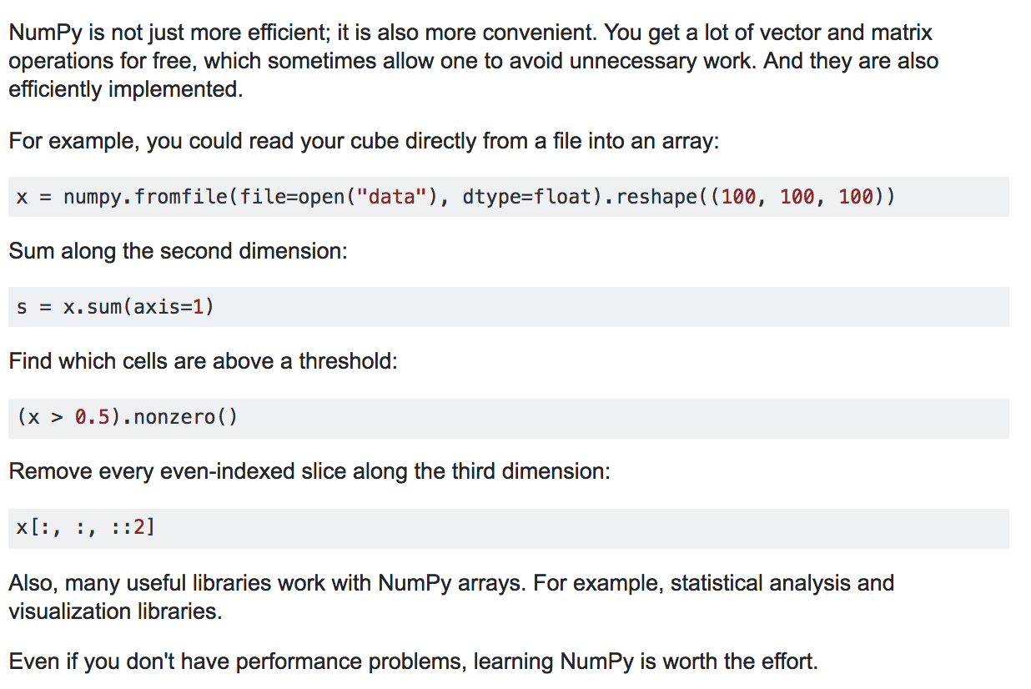

Pandas is a Python library for data analysis and data manipulation.

You use Pandas to load data into Python and perform your data analysis tasks. It is perfect for working with tabular data like data from a relational database or data from a spreadsheet.

Some important features to note include”

• **Manipulation**: moving columns, slicing, reshaping, merging, joining, filtering, and others.

• **Time-series Handling**: operations on date/times, resampling, moving windows and auto-alignment of datasets.

• **Missing Data Handling**: auto-exclude, drop, replace, interpolate missing values

• **Group-by Operations**: SQL like group by.

• **Hierarchical Indexing**: data structure level, powerful for efficiently organizing data by columns.

• **Summary Statistics**: Fast and powerful summary statistics of data.

• **Visualization**: Simplified access to plots on data structures, such as histograms, box plots, general plots and a scatter matrix.

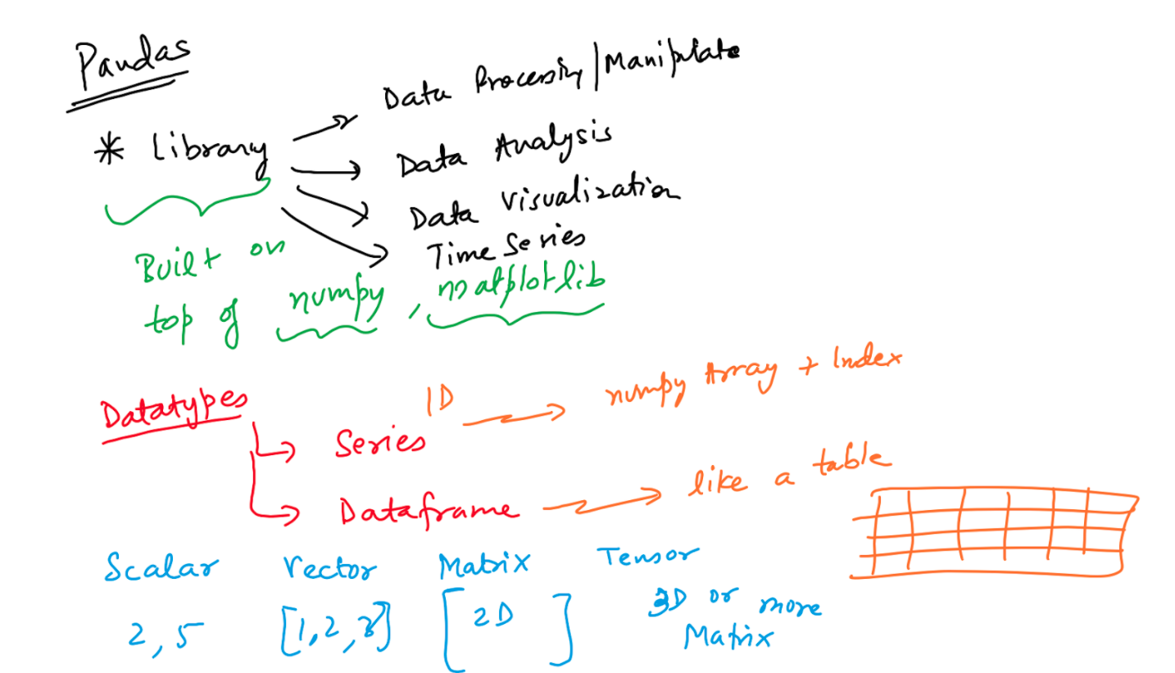

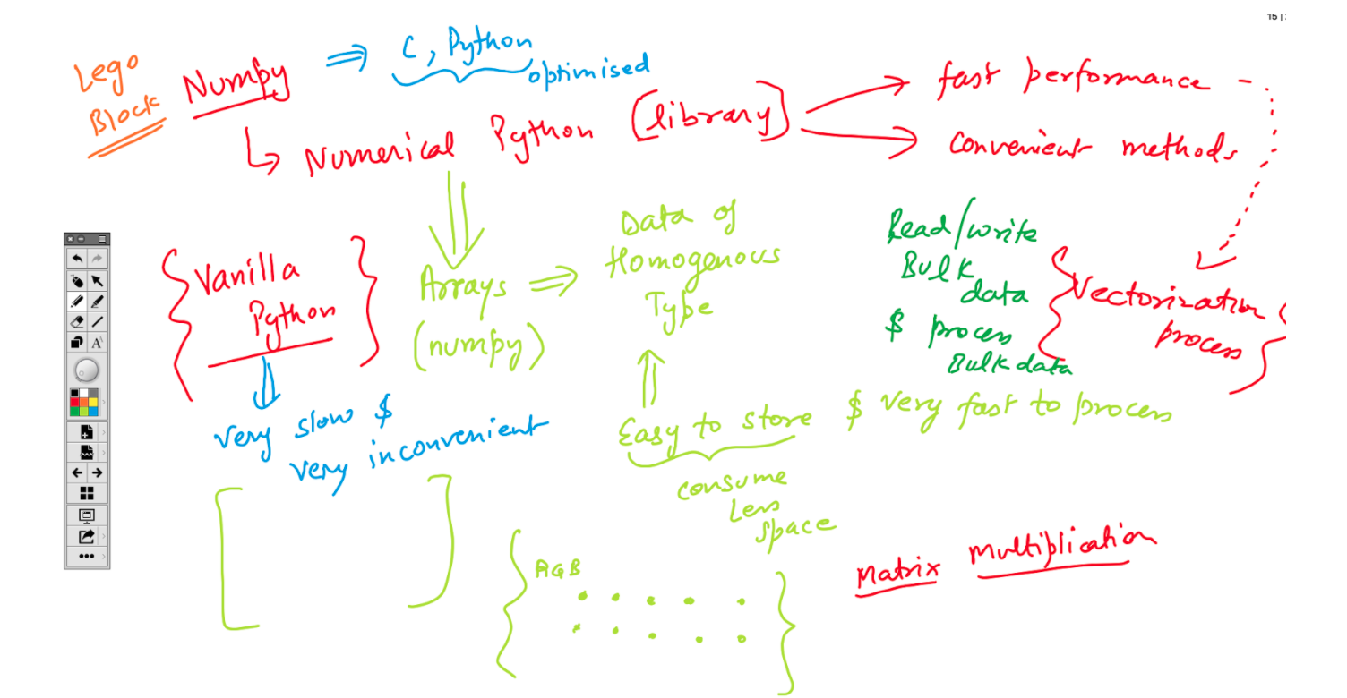

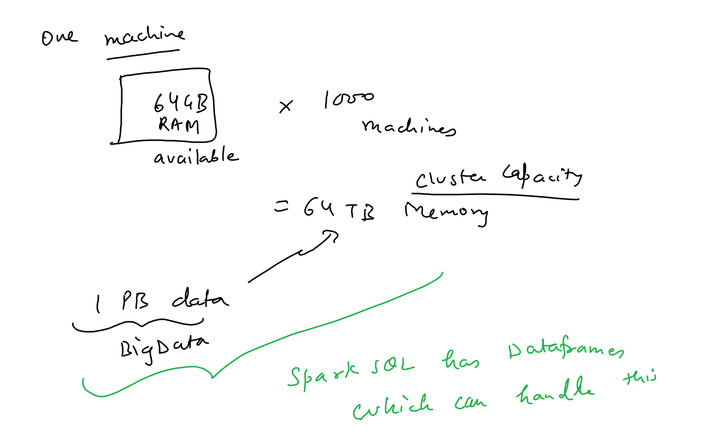

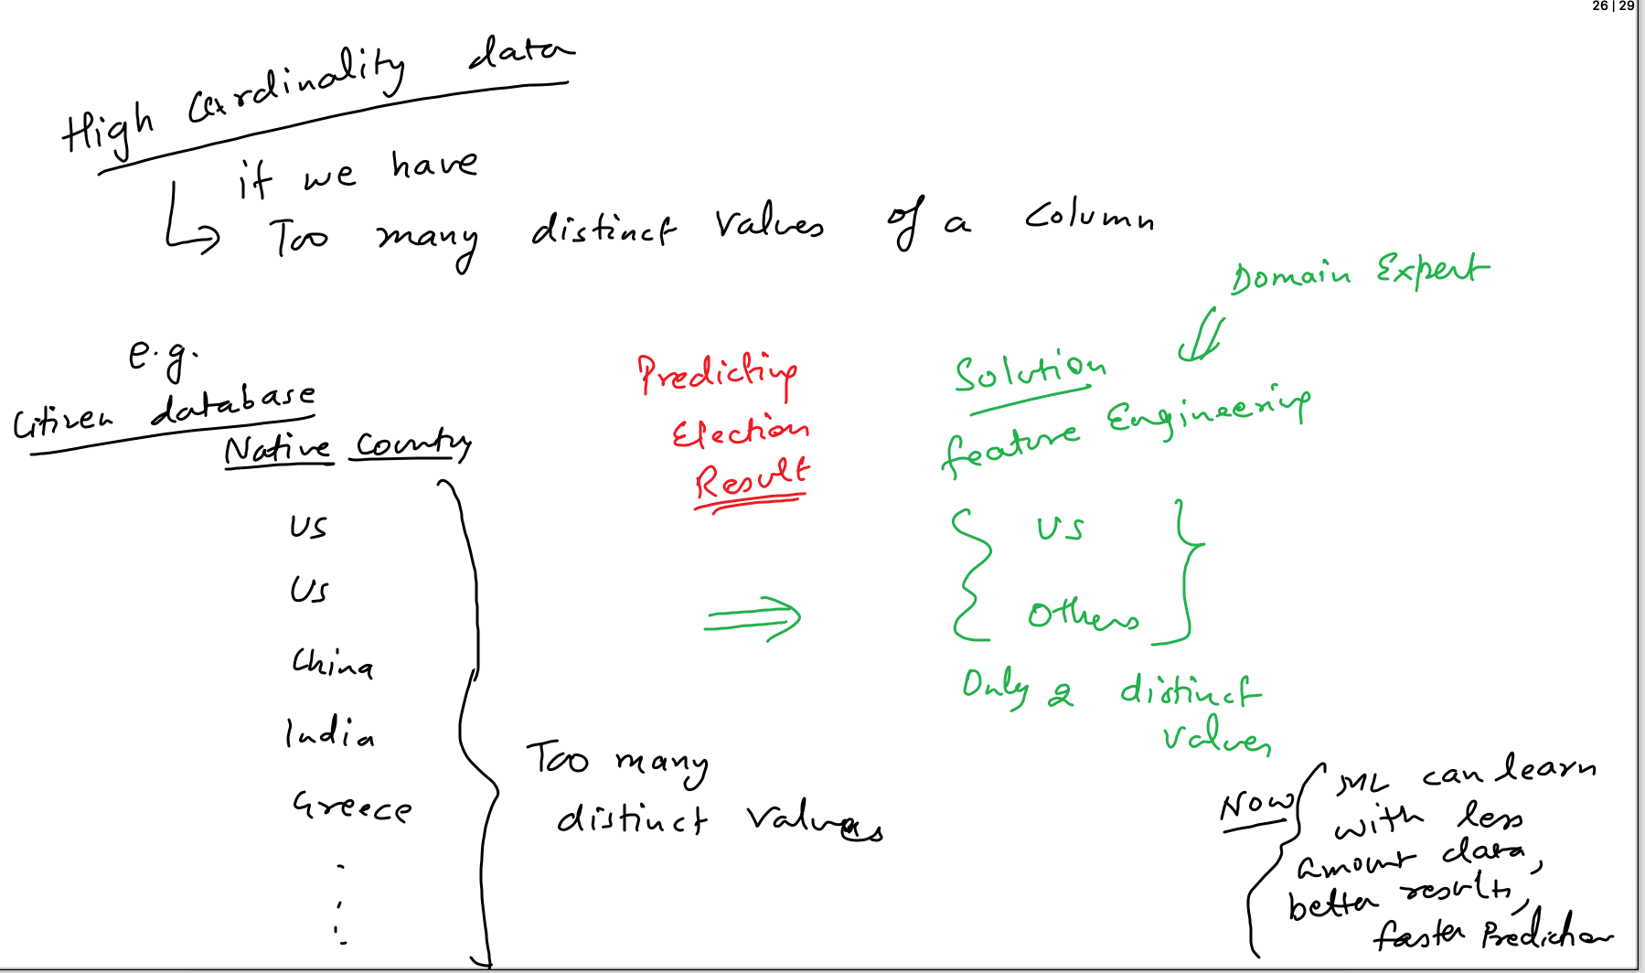

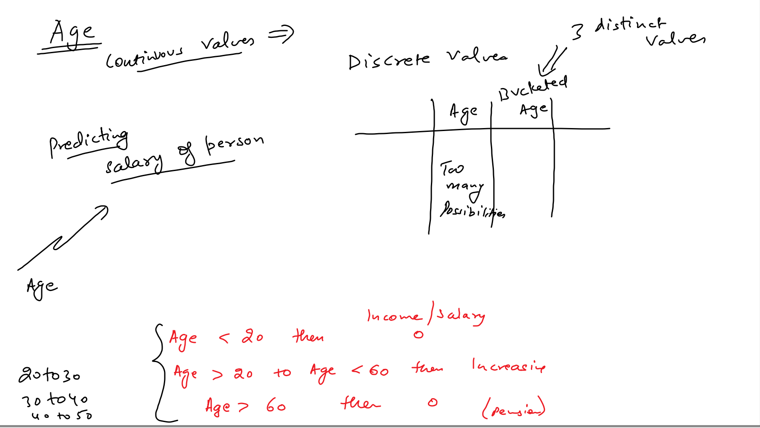

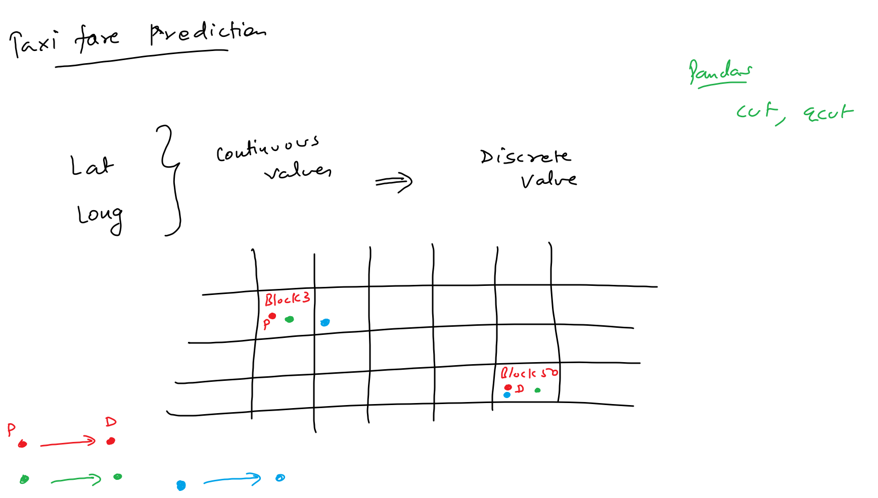

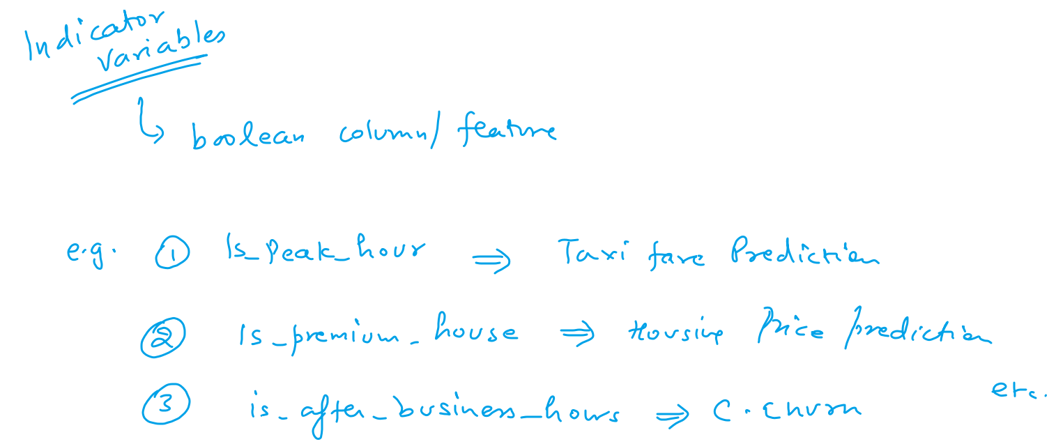

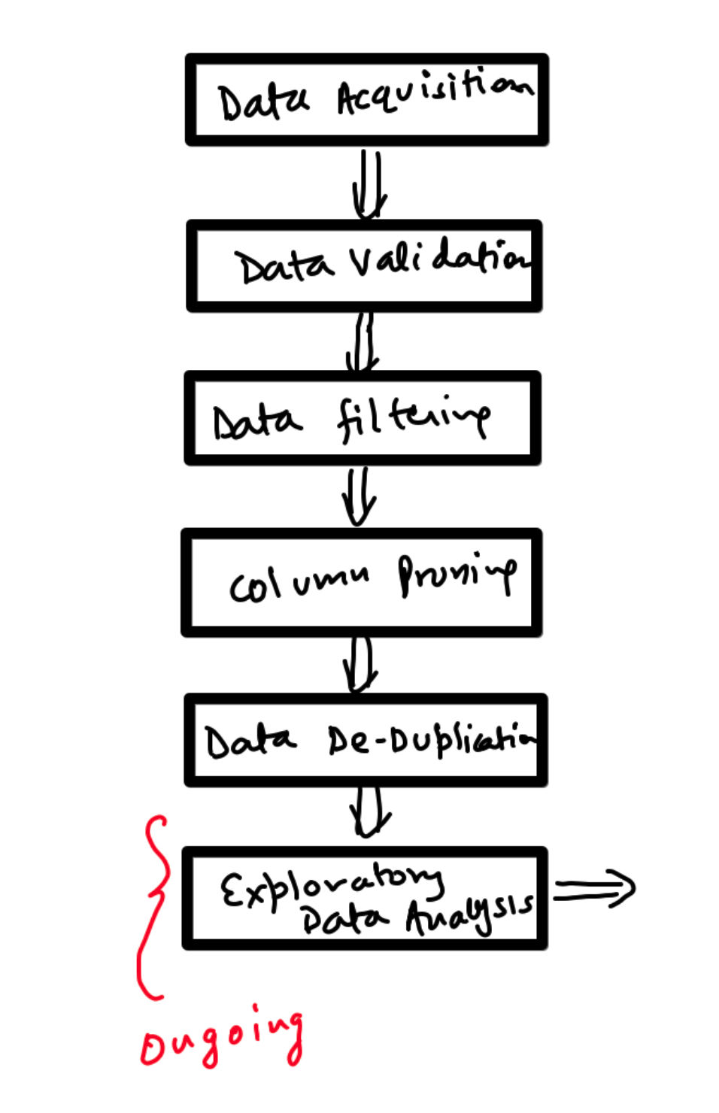

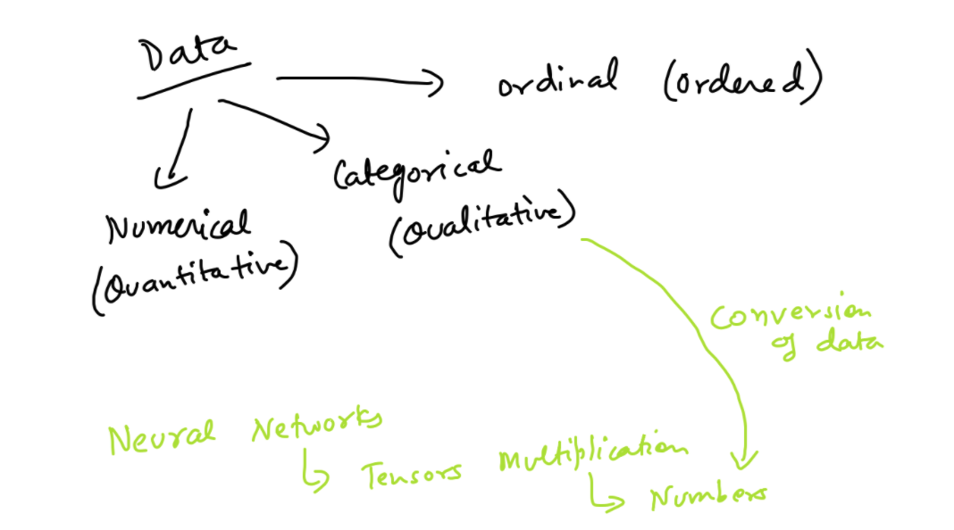

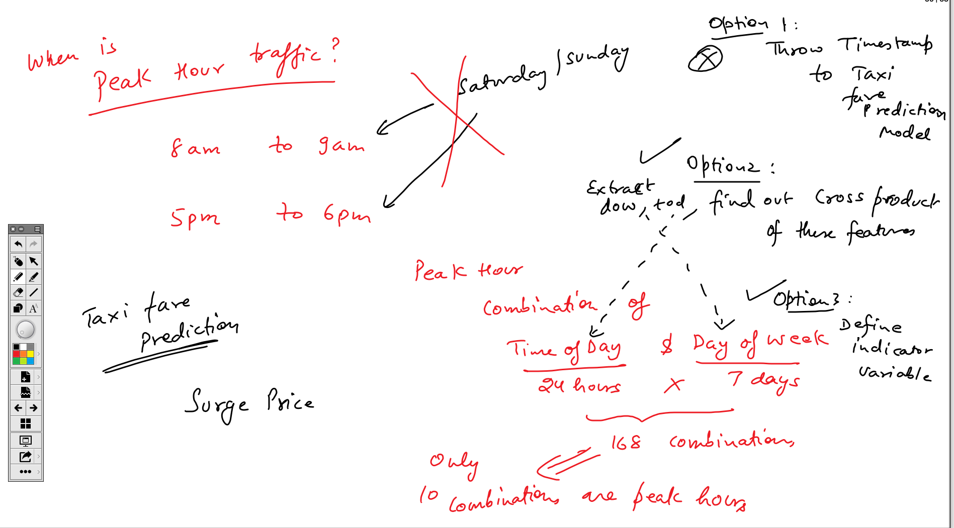

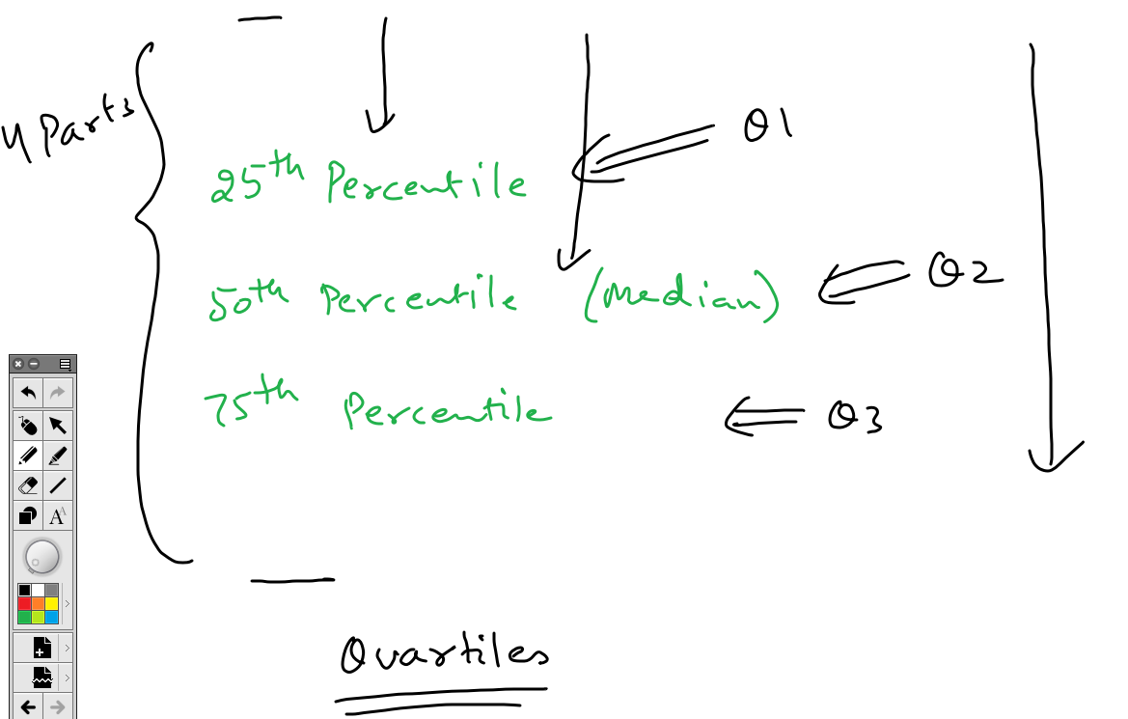

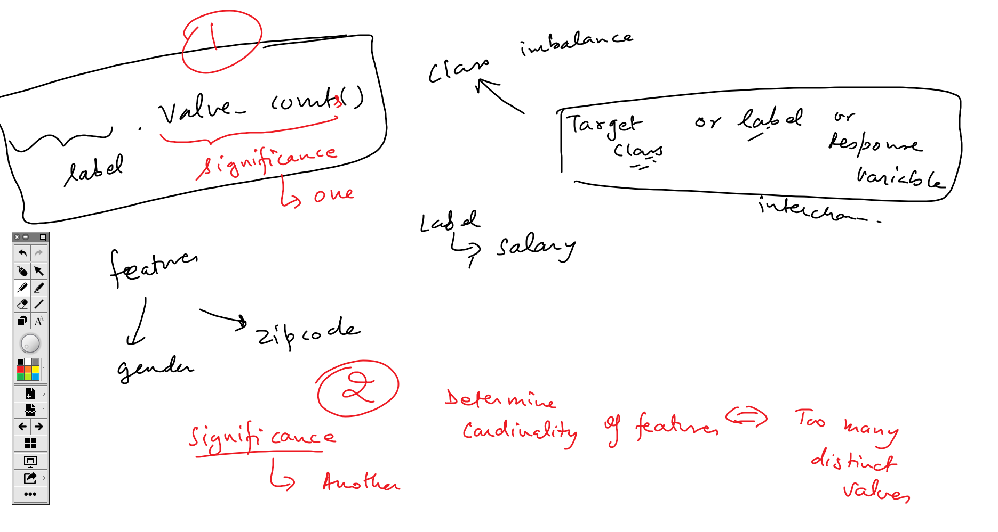

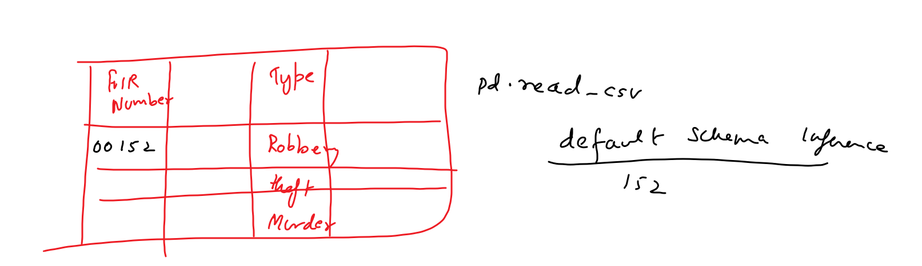

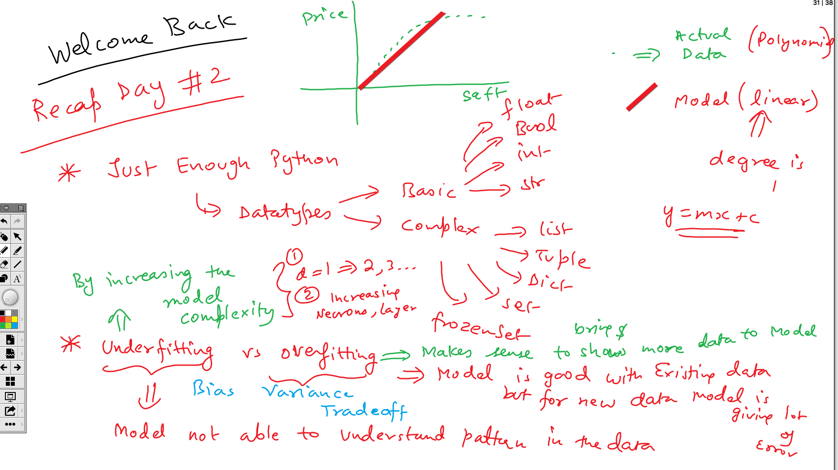

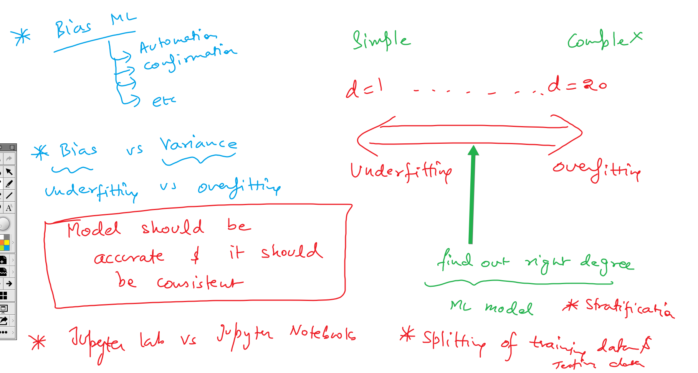

Pass Datatypes explicitly -

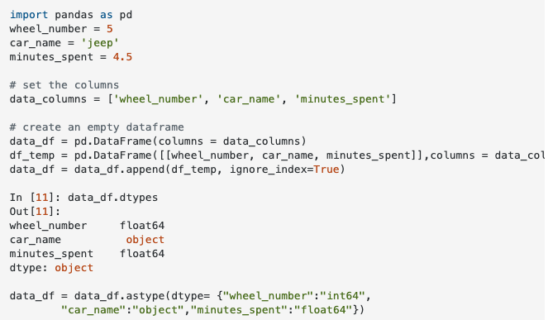

**Day 4: Data Visualization and Data Pipelines**

**Visualizing embeddings in Tensorboard**

[**https://www.youtube.com/watch?v=gDQfqRUyfBw**](https://www.youtube.com/watch?v=gDQfqRUyfBw)

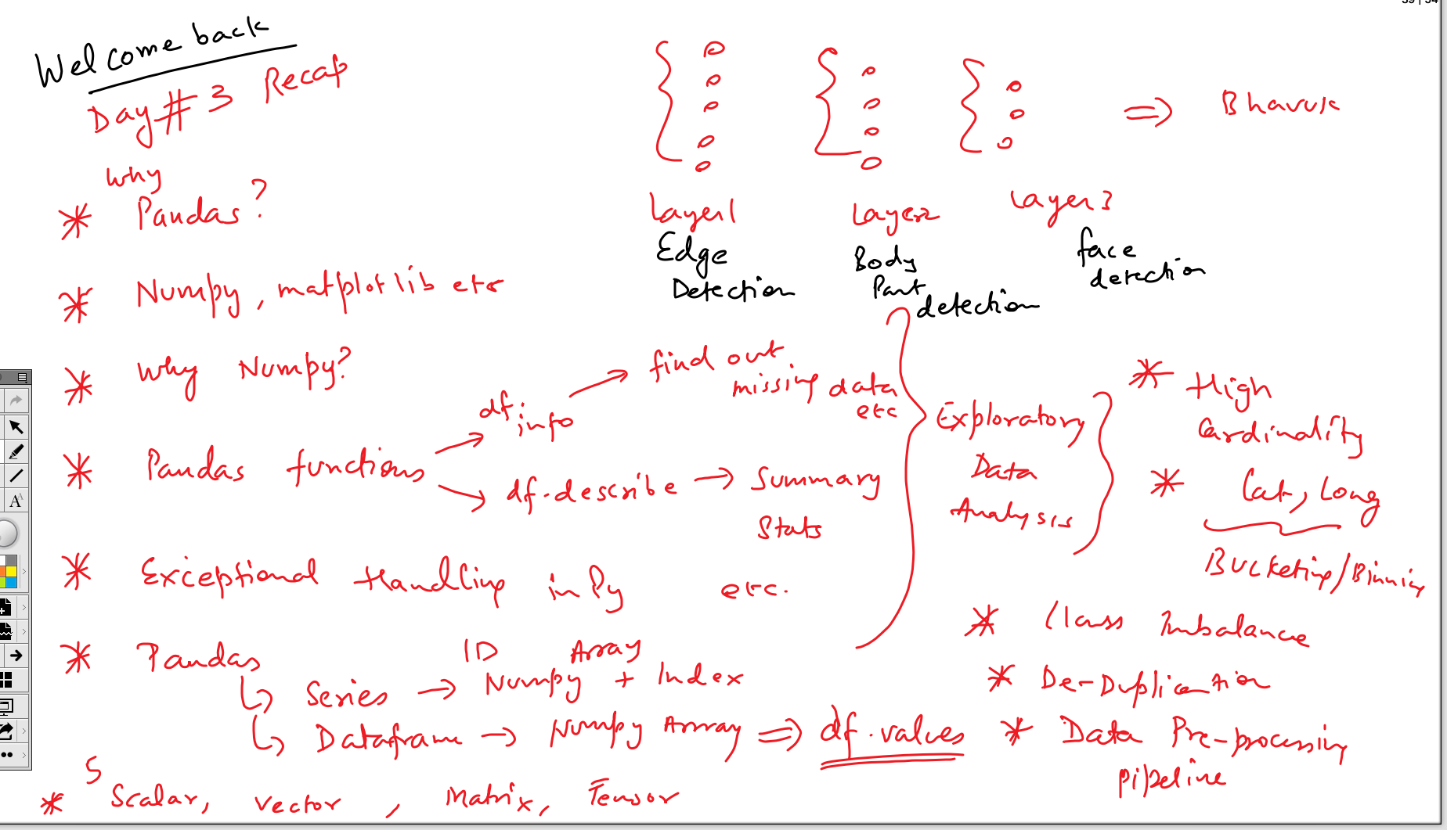

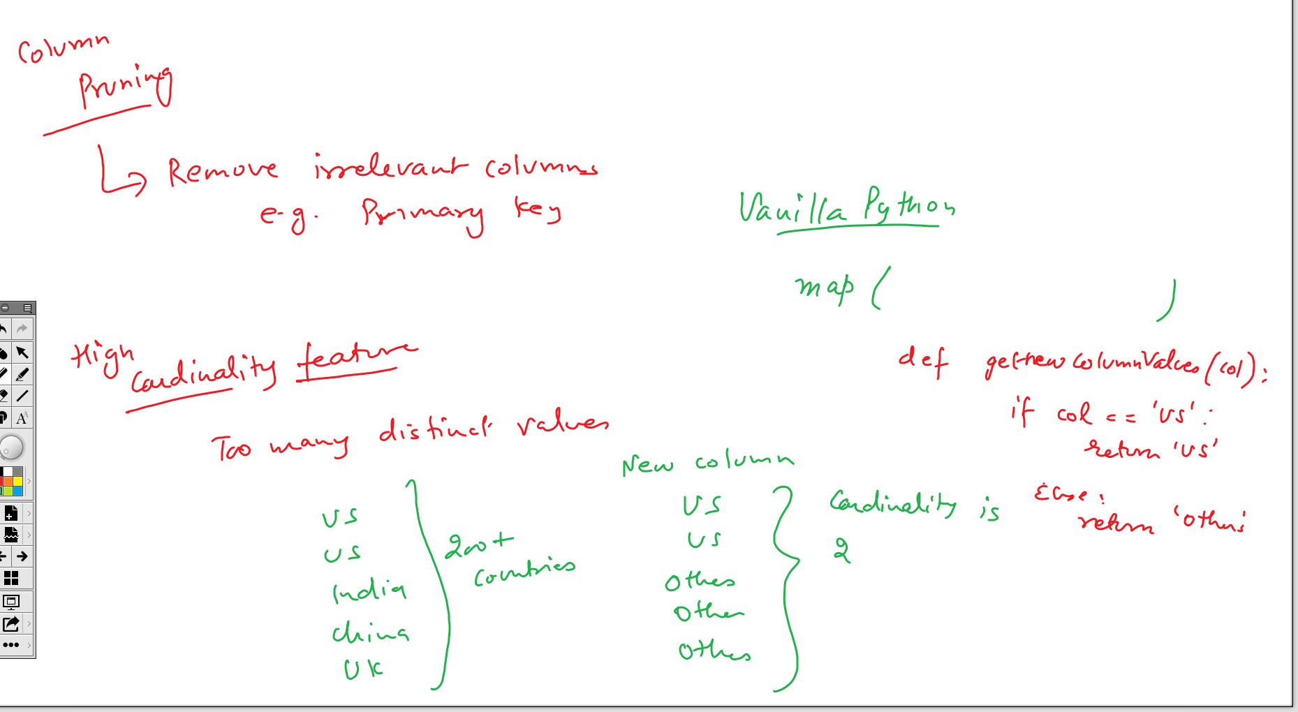

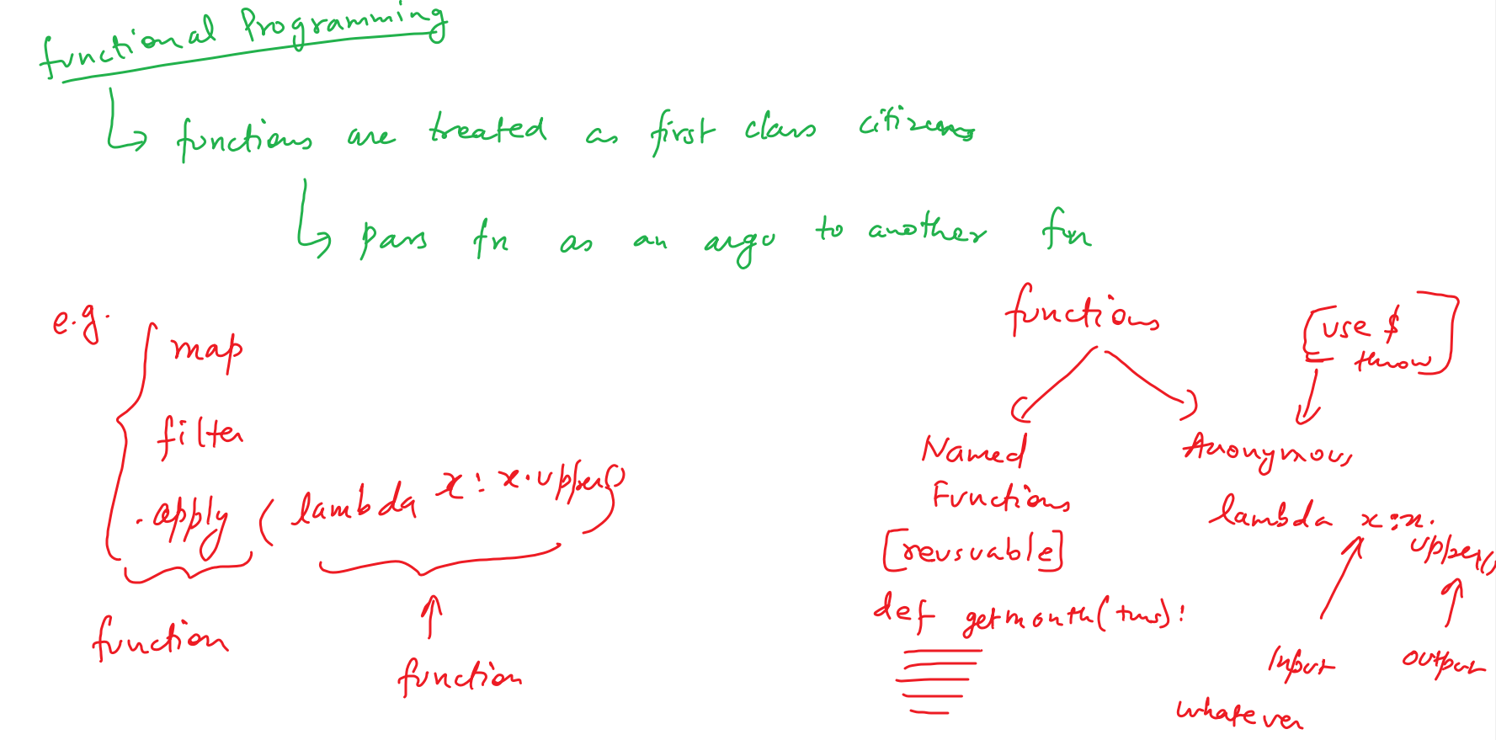

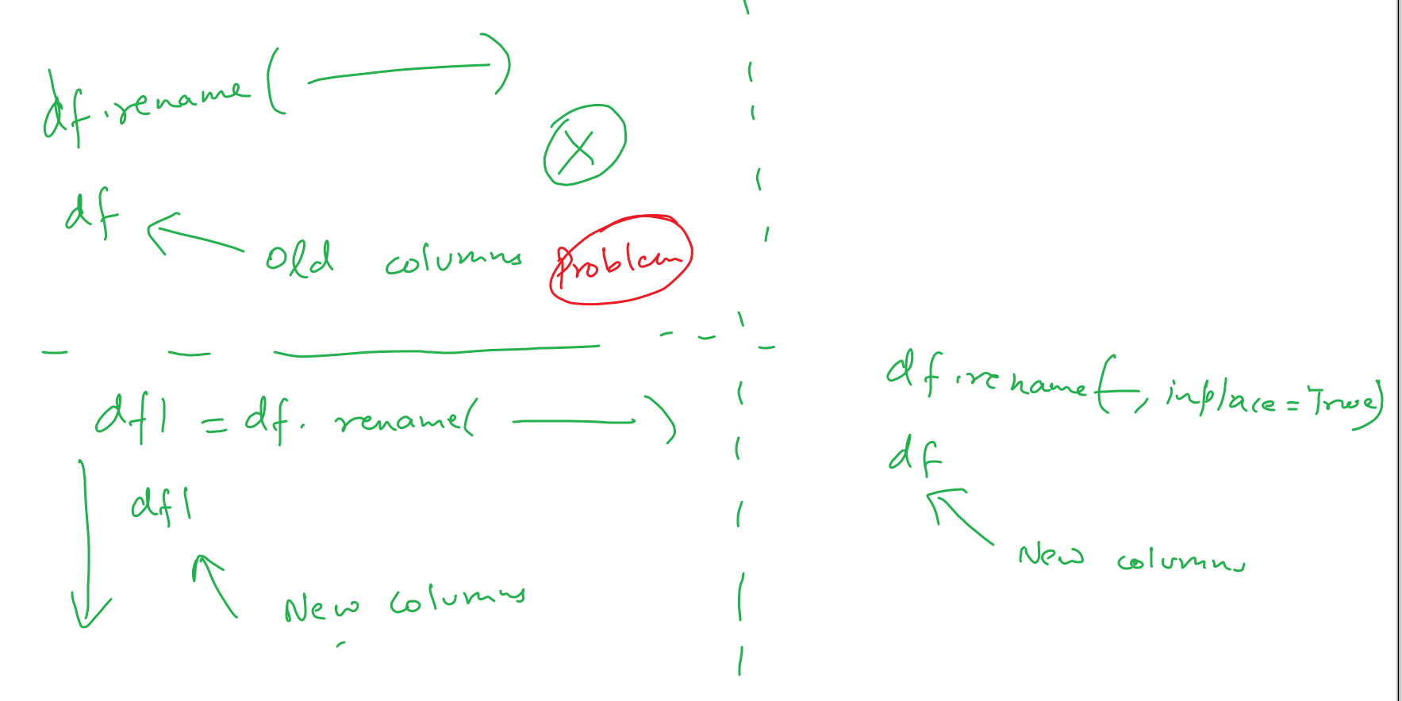

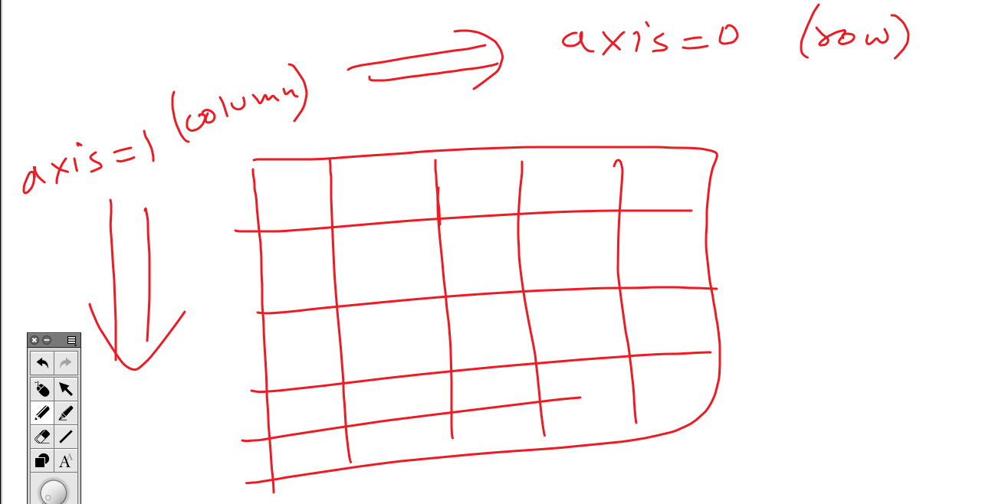

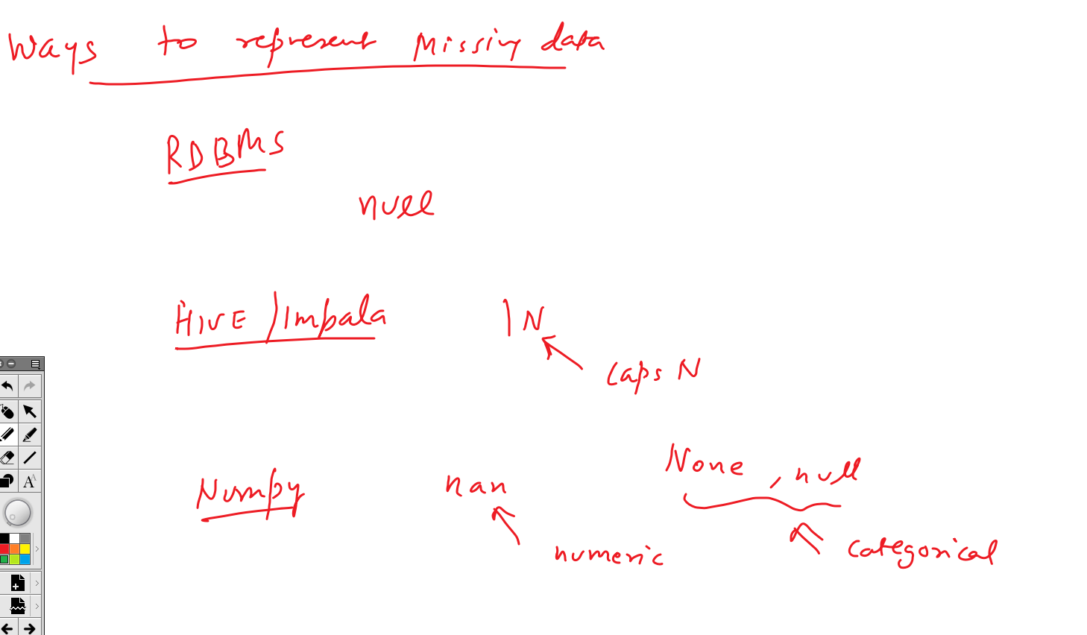

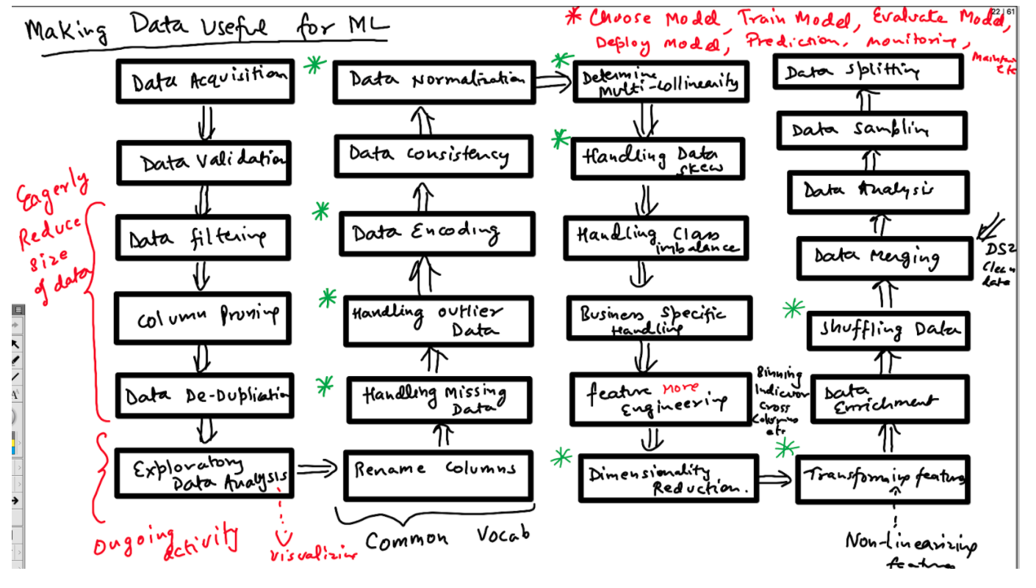

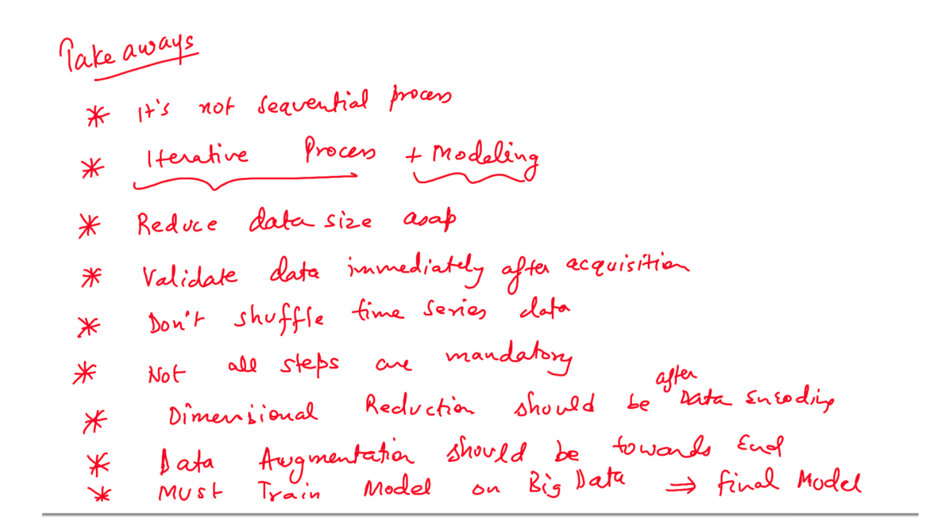

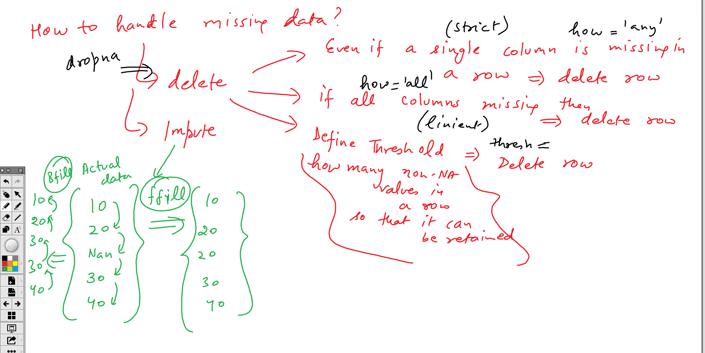

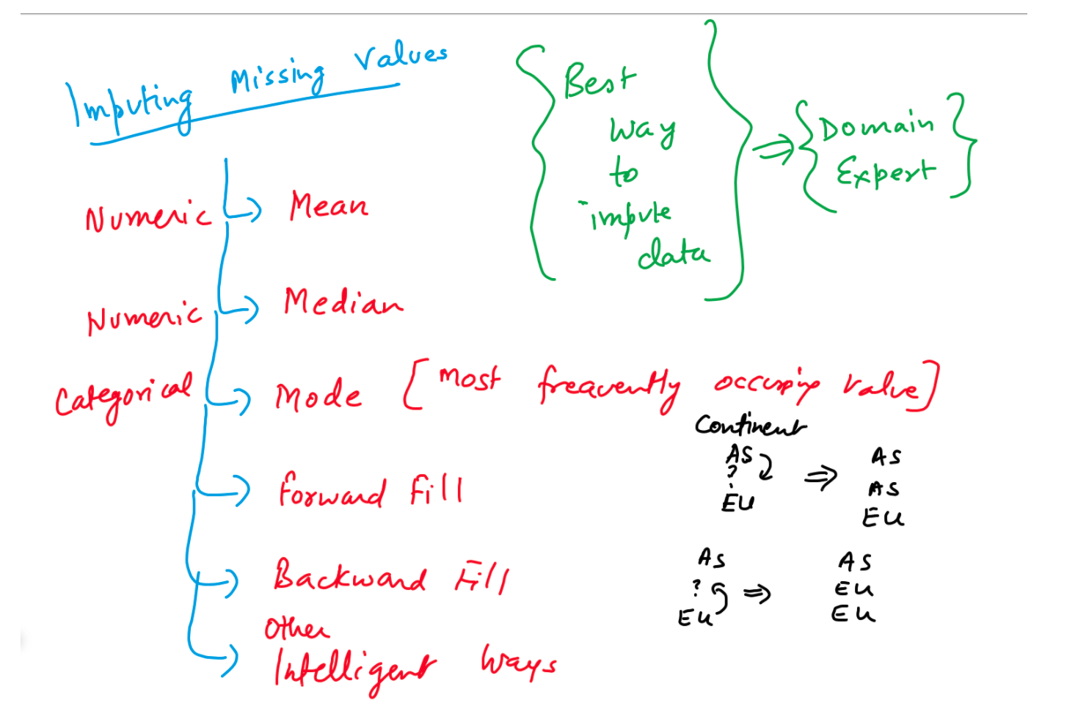

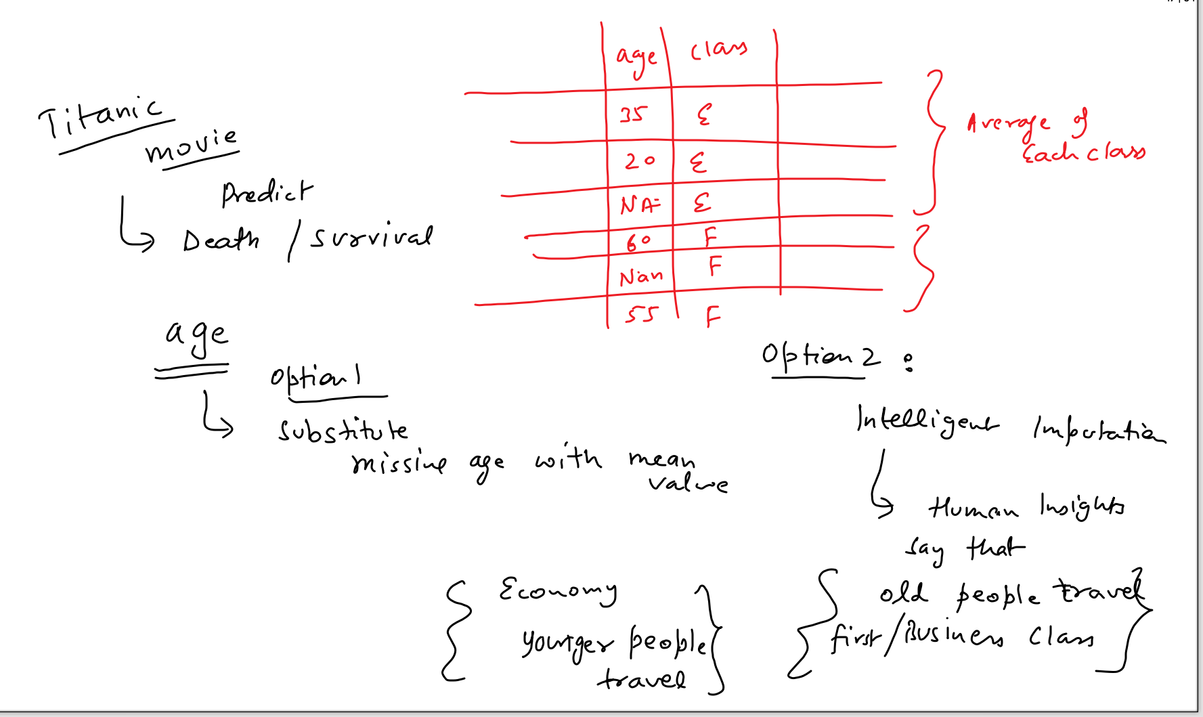

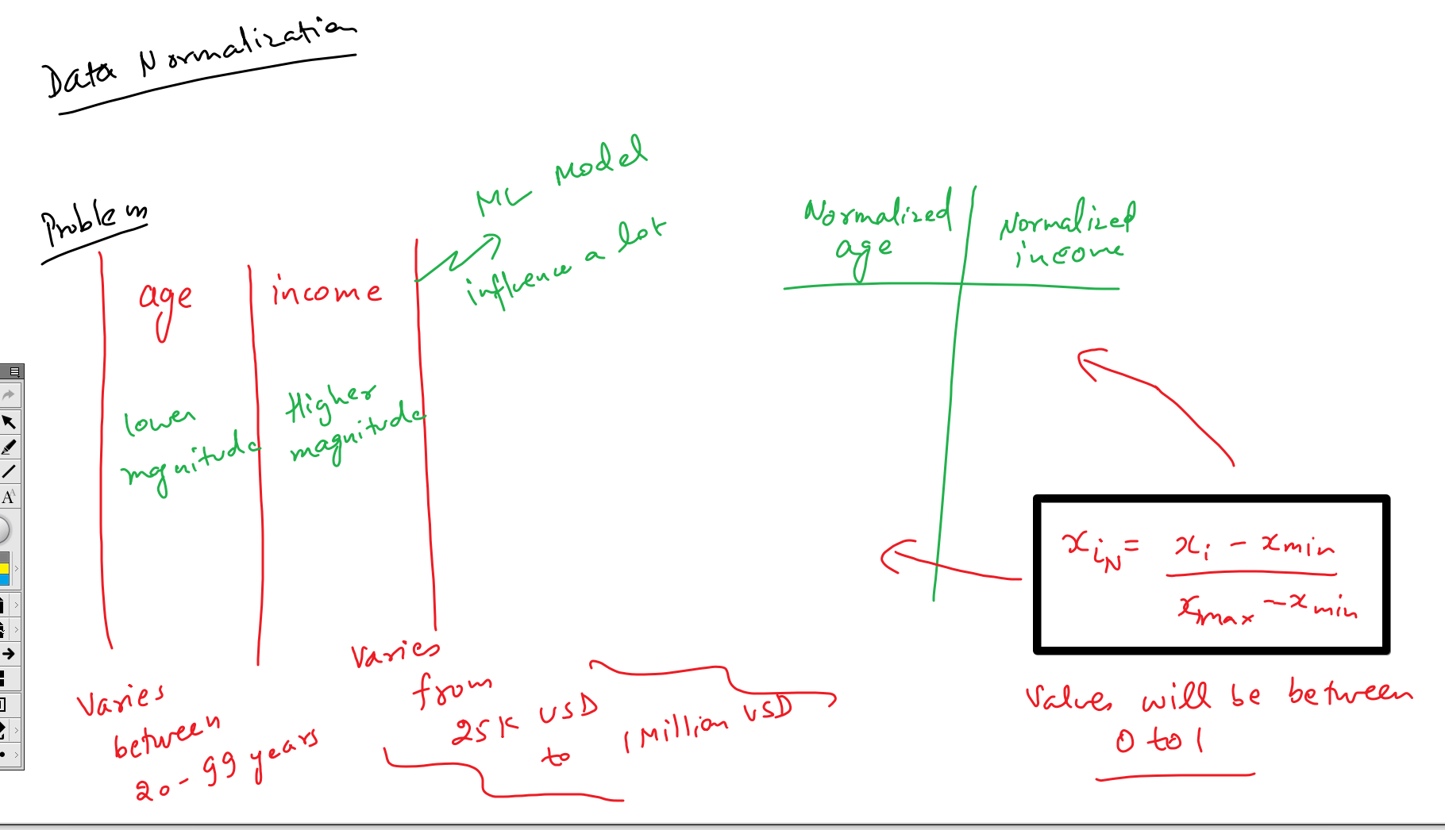

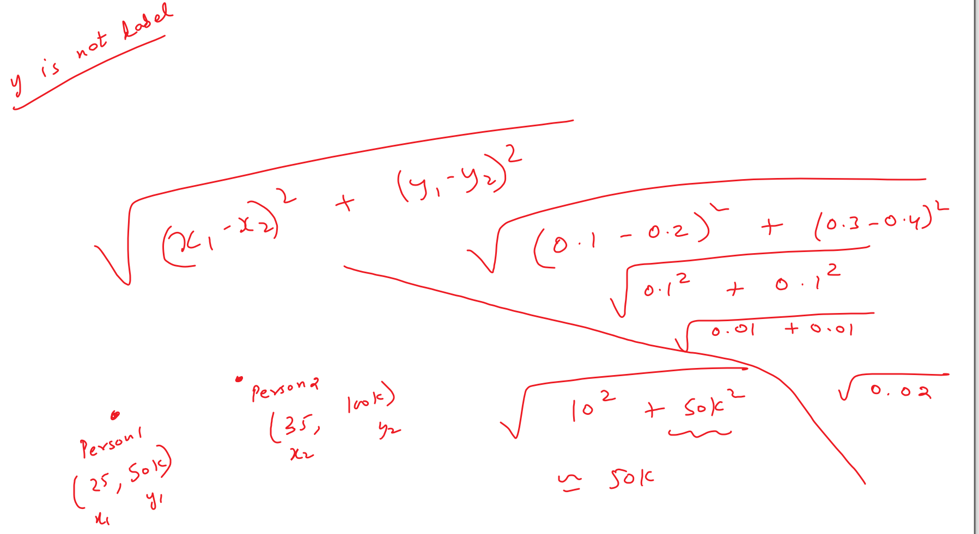

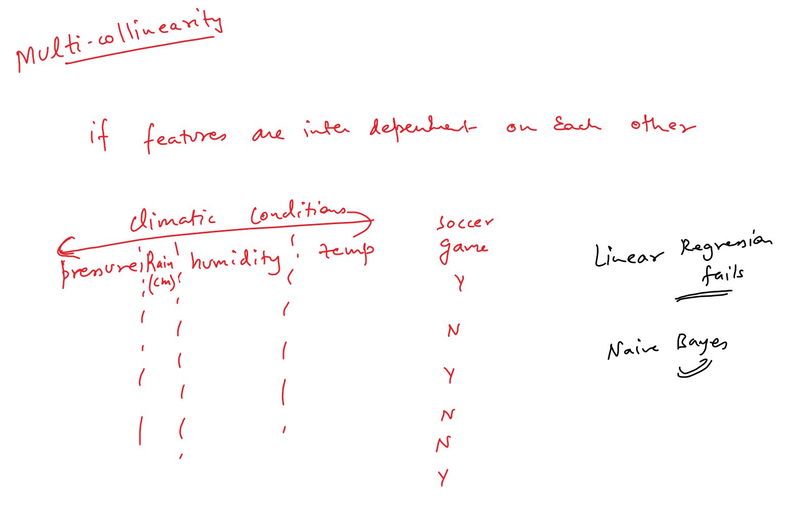

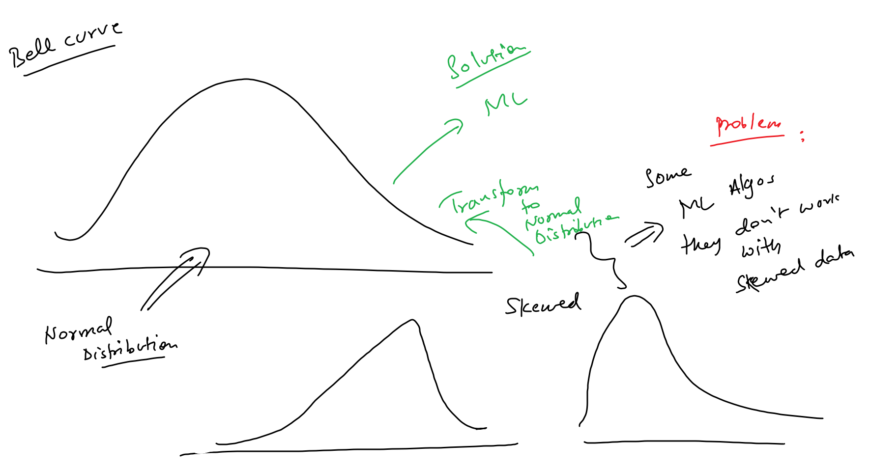

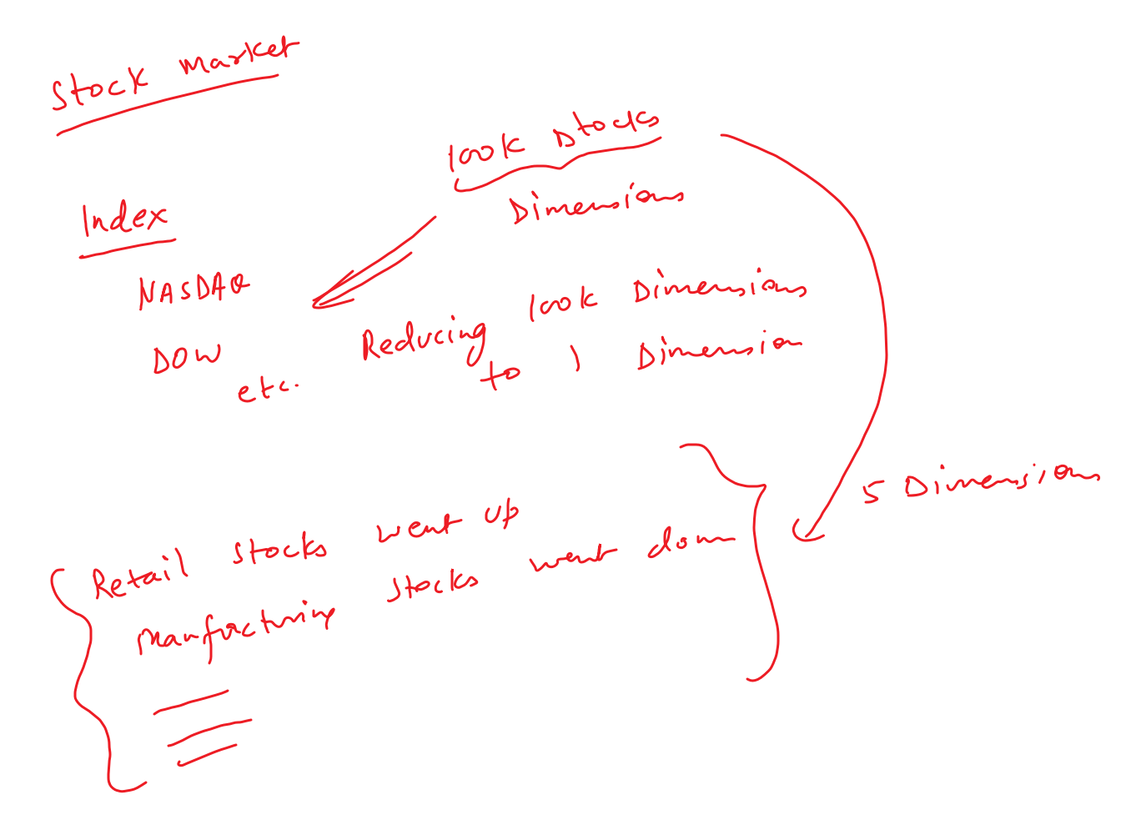

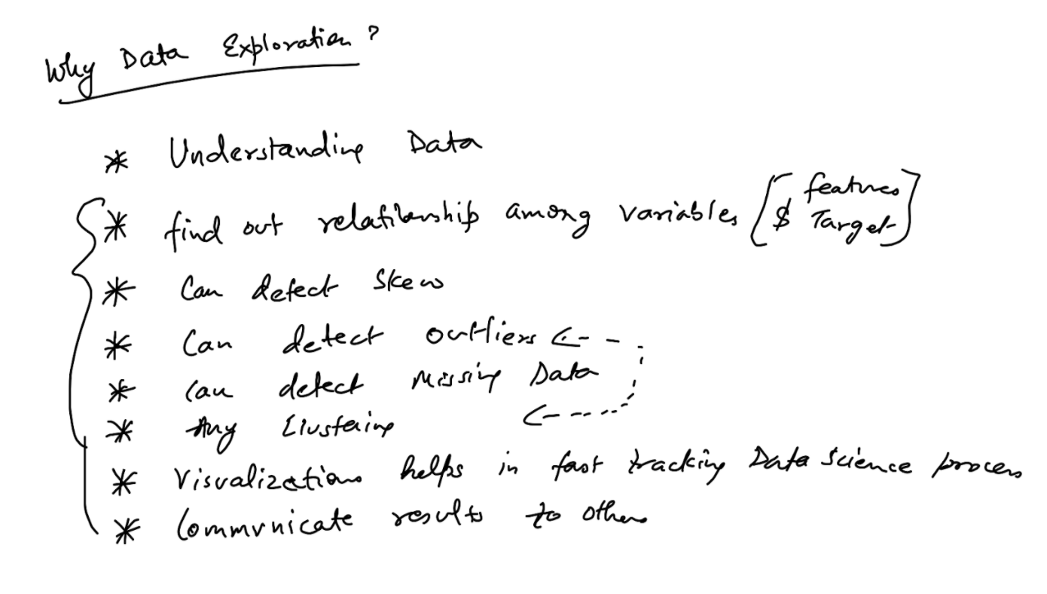

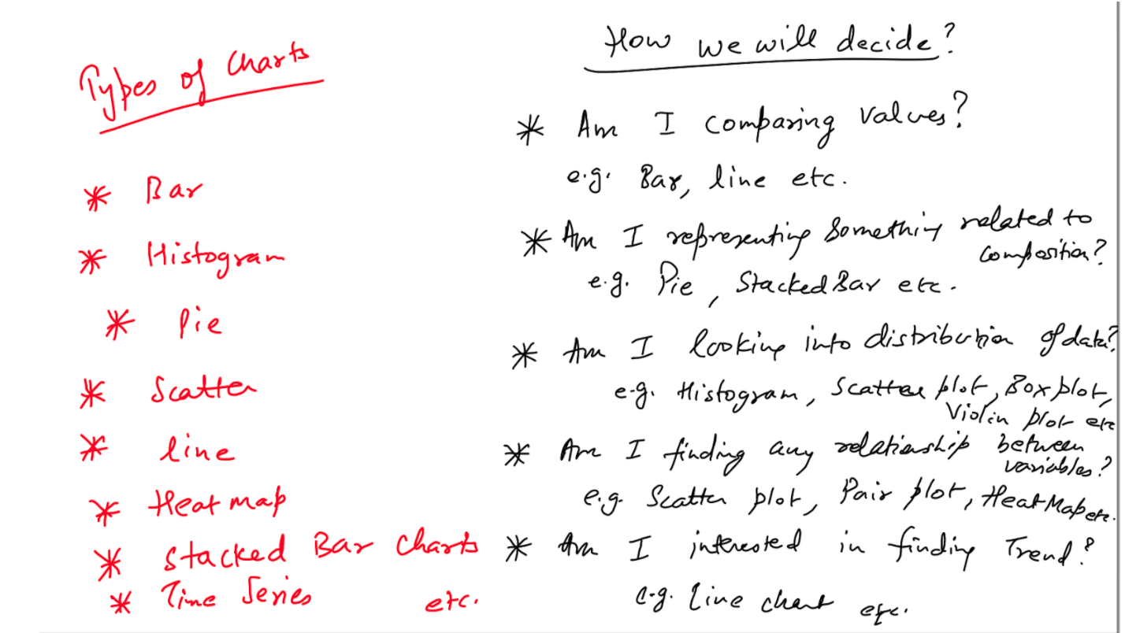

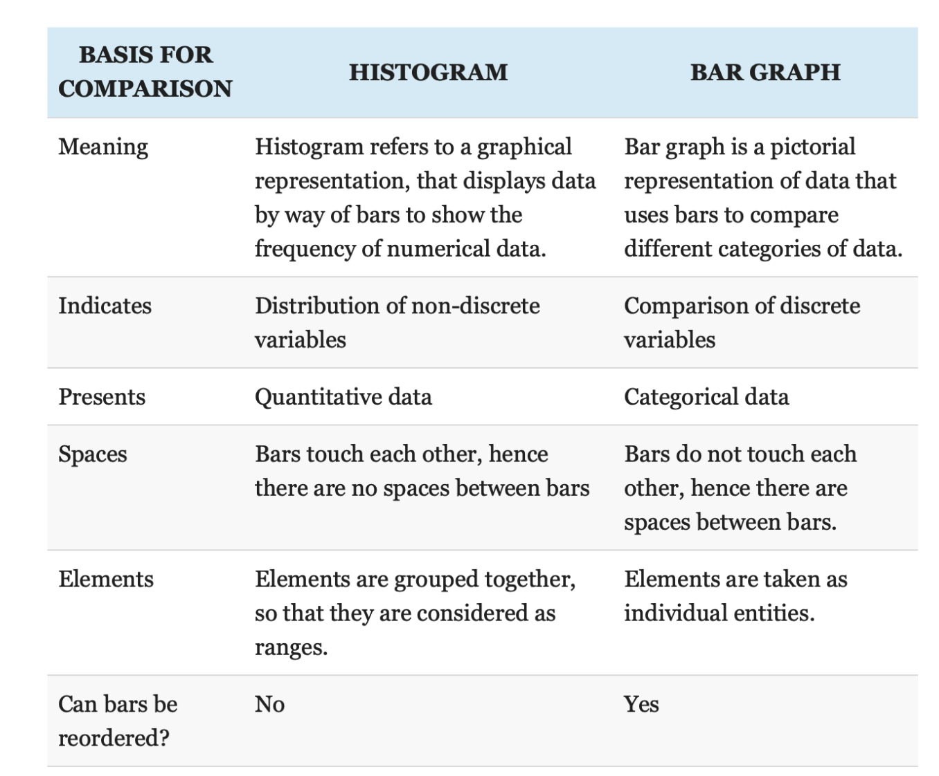

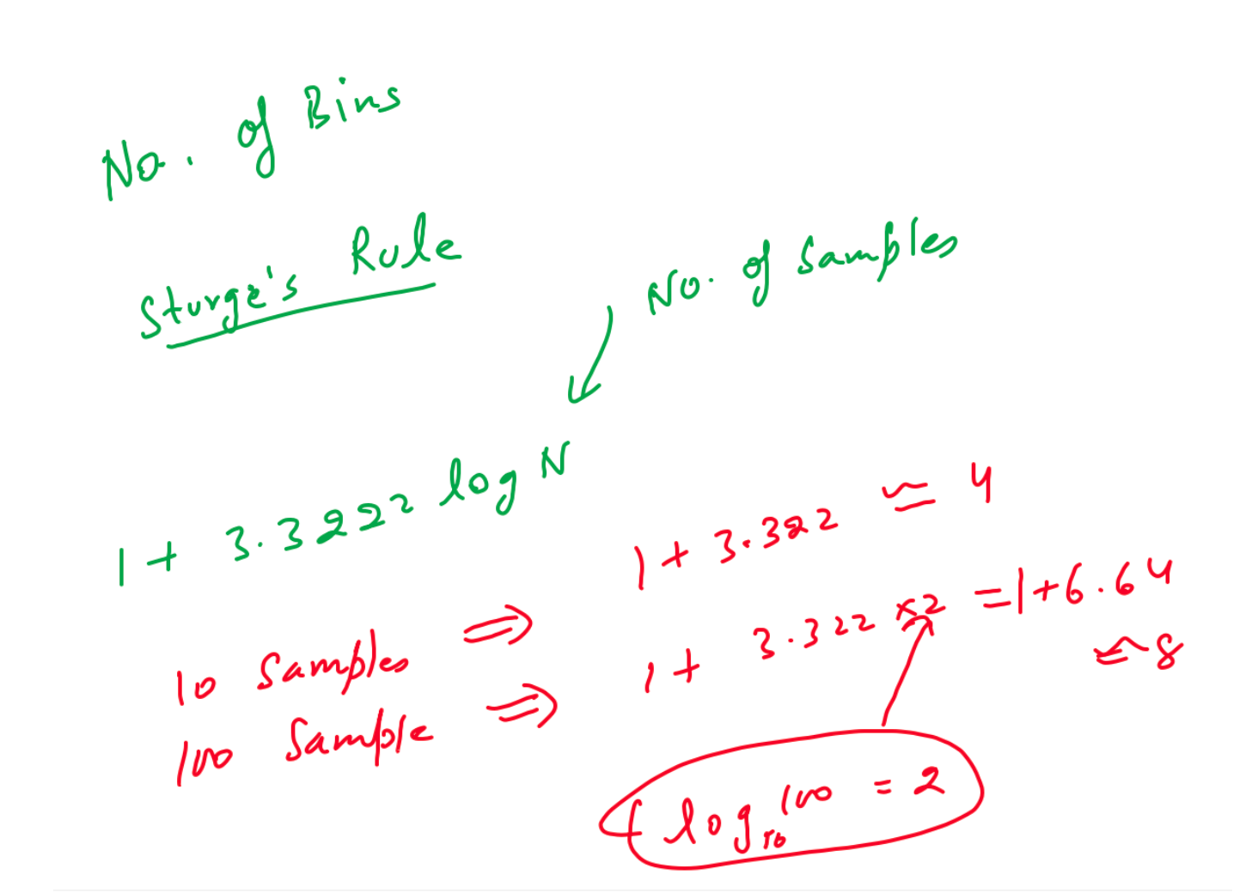

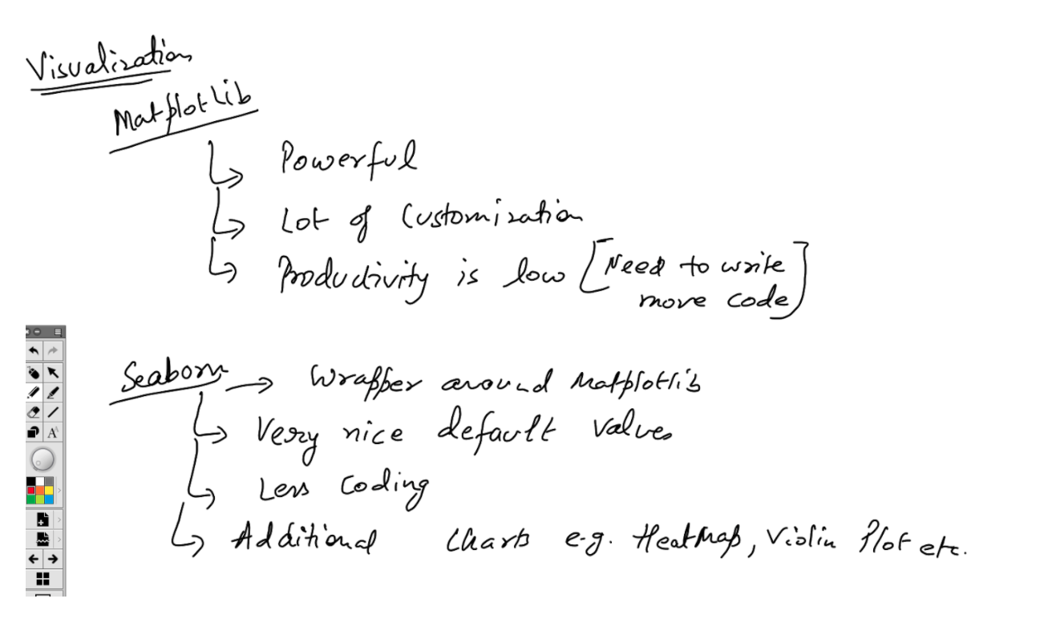

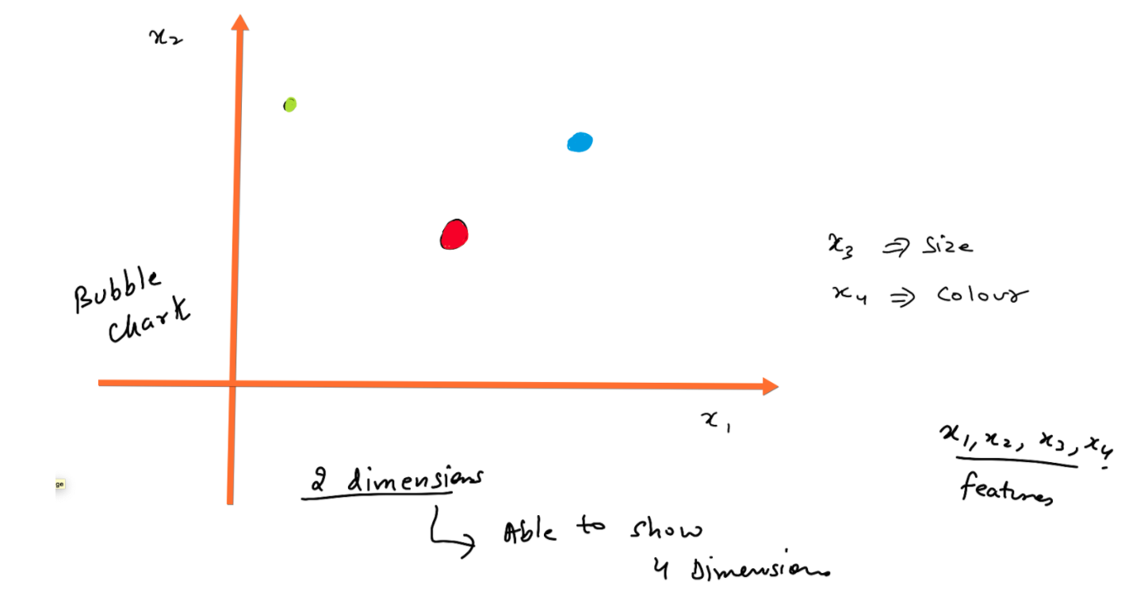

**Dropping column based on index =>**

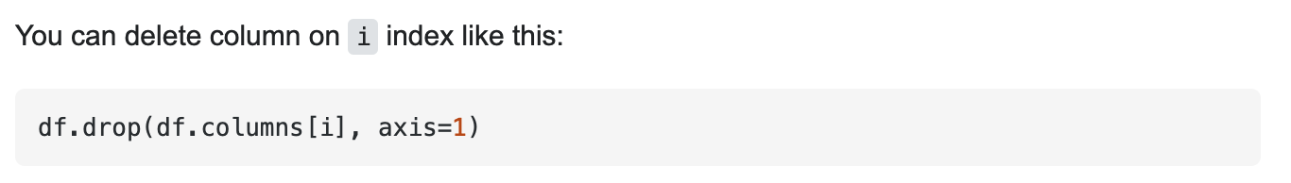

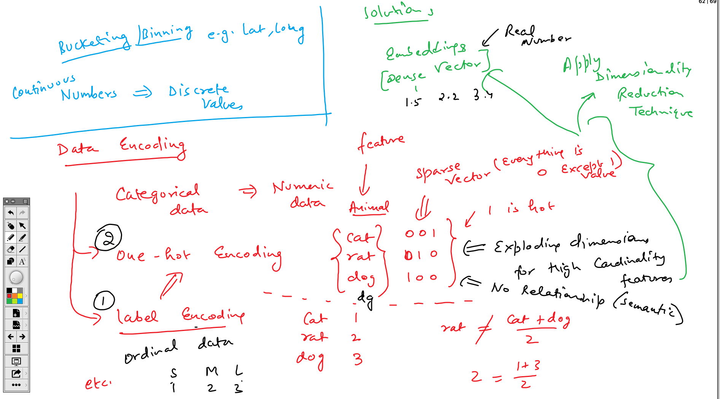

**Day 5 - Statistics**

Additional Notebook for Stats -

<https://drive.google.com/file/d/1k_10lp9r6uPXPoCIrHXkCjAgLTlWGzsr/view?usp=sharing>

https://towardsdatascience.com/essential-statistics-for-data-science-ml-4595ff07a1fa

